Question 1:
A matter of SIZE...

Millepora is a hydrozoan known as the “fire coral” because of its stinging cells. Examine any one of the specimens under a stereomicroscope. Are all the pores (in which individual polyps were living) of the same diameter or do they show more than one size (1a)?

What does this suggest about the polyps (1b)?

Are there septa in each pore, as in the scleractinian corallites shown below (1c)?

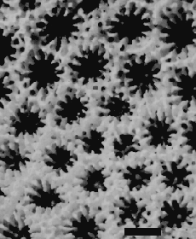
Left: Close-up photograph of Porites astreoides, a scleractinian coral showing 12 septa projecting inwards within each corallite.

Questions 2a, 2b:

Using the table below, how would you label the growth form of the species Millepora complanata and Millepora alcicornis (2a)?

Which species (M. complanata or M. alcicornis) developed a growth form adapted to relatively low water turbulence (2b)?

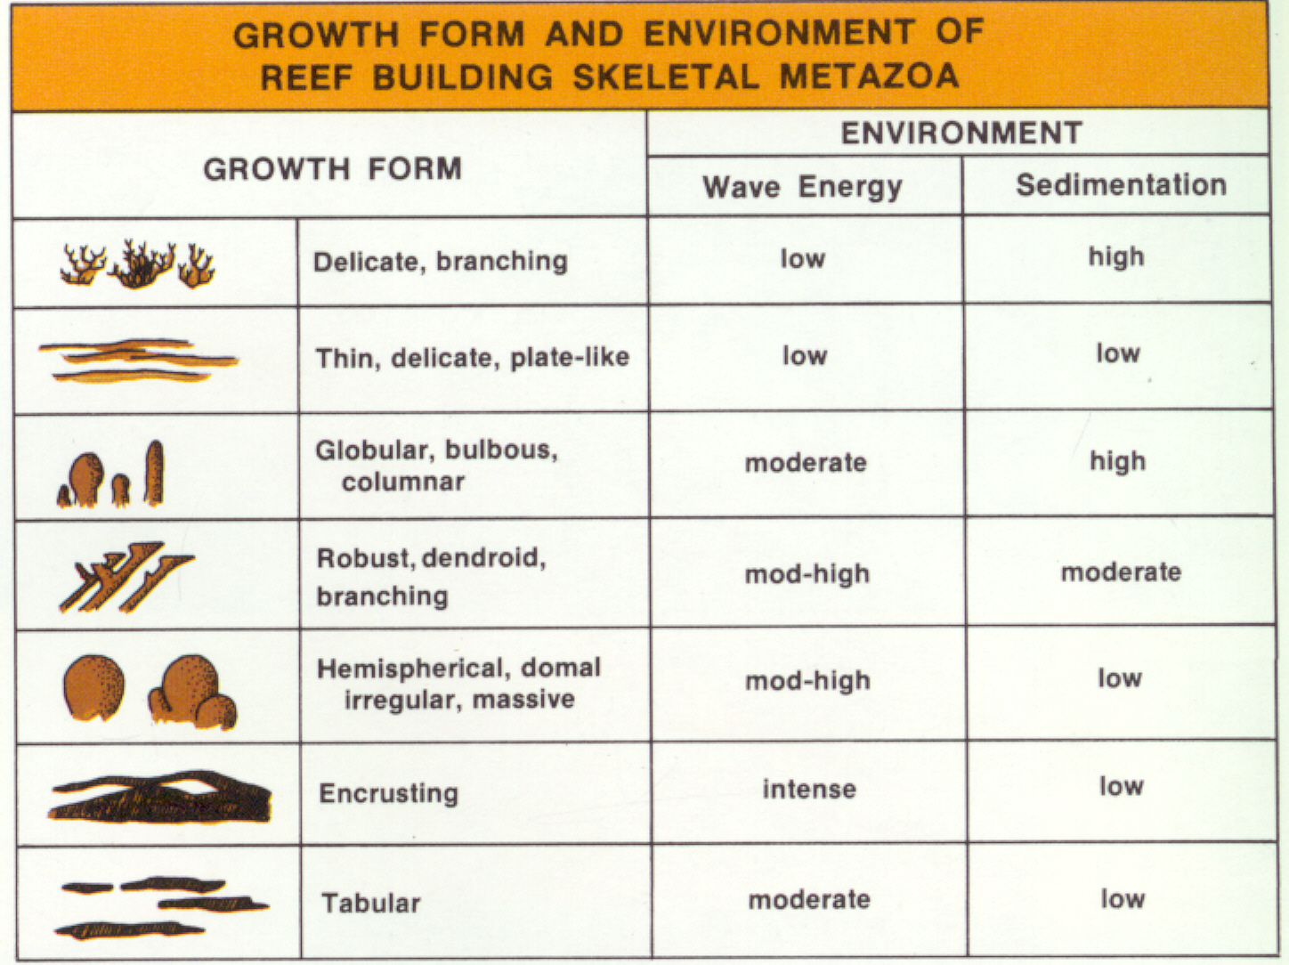
QUESTION 3:
SCYPHOZOA? The mysterious CONULARIDS

CONULARIDS are an enigmatic group (Cambrian-Triassic), now extinct, which is suspected of belonging to the cnidarians and more precisely the scyphozoans (true jellyfish).

Examine and sketch the specimen provided (3a). The good preservation is due to the calcium phosphate composition of its skeleton, but conularids are rarely preserved whole.

Was it anchored to the bottom, swimming or floating (3b)? Check the Paleozoic diorama of marine life, in the lobby of the Redpath Museum, for one possible interpretation. Some have been found whole, in assemblages attached to tubes or nautiloid shells…
QUESTIONS 4.a-e:
SCLERACTINIAN CORALS

Examine the scleractinian corals set aside for this question: Fungia, Oculina, Diploria, Agaricia, Siderastrea, Isophyllia, Porites.

Several of the specimens are colonial. One is not: name the single genus of solitary coral (4a).

Colony form, which describes the relations of the corallites in a colonial coral, is described separately from colony habit (ramose, platy, massive, etc…)

Find a genus of colonial coral whose form can be described as plocoid (4b), i.e. where individual corallites are separated by skeletal tissue (the coenosteum).

Other examples of common forms are "cerioid" (corallites juxtaposed), "meandroid" (corallites sharing septa and arranged in multiple series) and "phaceloid" (corallites separated by void space).

Find a genus of colonial coral whose habit can be described as branching (syn. ramose) (4c), massive (4d), platy or bladed (4e).
Question 5:
SEPTAL PATTERNS

Sketch the shape of a single corallite from either Galaxea or Porites (indicate its genus and specimen number) (5a).

For the next part, focus on a single quadrant of the corallite. Label on your sketch as “1st”, “2nd”, “3rd”, the different orders of visible septa (“orders” of septa means septa of different sizes that are repeated either 6, 12 or 24 times).

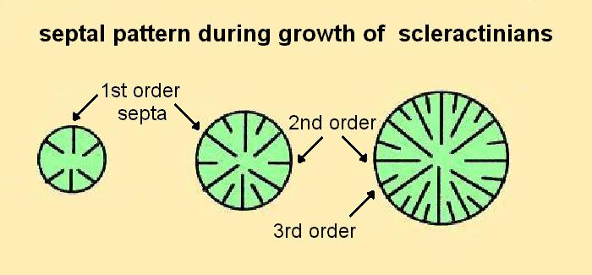
Are the larger septa more or less numerous than the shorter septa (5b)?

QUESTION 6:
SCLERACTINIAN COLONIES

You may have noted in Question 4 that the colonies display different degrees of corallite integration. Choose any one of the colonial corals and describe in your own words the relations among corallites (6).

For example:
- does each corallite have its own wall?
- are the corallite walls separated by empty space?
- are the corallite walls separated by skeletal tissue that is neither corallite walls nor septa?
- if walls are absent, do the septa of adjacent corallite simply touch or do they merge?

QUESTION 7:
TABULATE CORALS

family Tetradiidae

In Tetradium the corallites are square and have 4 partitions that resemble septa. When the partitions grow to meet towards the middle, the corallite is divided into 4 new corallites.

Examine a specimen showing a polished surface under a stereomicroscope and sketch four adjacent corallites containing these partial partitions (7).

QUESTION 8:
TABULATE CORALS

family Favositidae

The genus Favosites is very widespread in Silurian and Devonian shallow-water marine limestones.
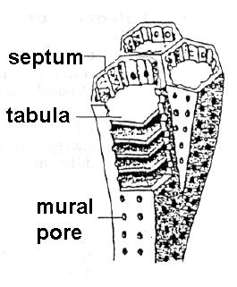

Make a sketch of Favosites. Include a longitudinal section (8a) and a transverse section (8b), labelling the tabulae, septa and the extent of one individual corallite. Do not forget to include a bar scale in all drawings.

NOTE: The mural pores are not often visible in specimens. This is because the tubular corallites were either filled by sediment or permineralized by calcite.

OBSERVATION ONLY:
TABULATE CORALS

family Halysitidae

The family Halysitidae is familiarly known as the "chain" corals. The corallites are attached to each other only along two edges and form loops that are chain-like in transverse section. Halysites and Catenipora are representative.

Manipora is a late Ordovician genus with more than one row of corallites in each rank.
OBSERVATION ONLY:
TABULATE CORALS
family Auloporidae

Aulopora is a creeping, encrusting genus composed of trumpet-shaped corallites with tabulae widely spaced or absent.

Look at the specimens: can you see where this coral covers other organisms?

QUESTION 9a:
TABULATE CORALS

family Syringoporidae

Examine the specimens of Syringopora (PT0660) a very common genus (Silurian to Carboniferous) in which cylindrical corallites are filled with nested funnel-shaped tabulae.

Is there evidence of connections among separated corallites (phaceloid form) or branching (dendroid form) among the corallites? (9a)
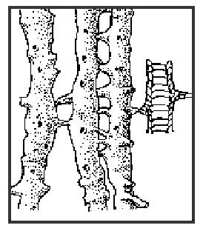
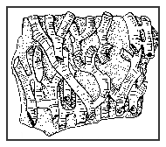

Phaceloid colony Dendroid colony

QUESTION 9b:
TABULATE CORALS

family Syringoporidae

You saw this specimen in an earlier laboratory exercise.

What is its mode of preservation?

Where could the mineral replacing the CaCO₃ hard parts have come from (think back to last week's lab)?

Are the corallites likely to be filled by the same material as the space between them?
QUESTION 10:
TABULATE(?) CORAL

Family Heliolitidae

Examine the commonest genus Heliolites.

Why are heliolitids sometimes classified apart from other tabulates (10)?

Remember: tabulates are generally composed of
- small corallites with well defined walls divided by tabulae. - septa are reduced to vertical rows of spines or absent.
- corallites typically closely juxtaposed (cerioid form) or in chain-like strings.

Does Heliolites deviate from any aspect of this description? You may want to compare it to Favosites and Syringopora (shown for Questions 8, 9) which are more typical tabulate corals.

Right: fragment from a typical tabulate favositid…
QUESTION 11:
SOLITARY RUGOSE CORALS

Draw a cross section of either Streptelasma or Caninia one of these genera and show the relationship of the tabulae, dissepiments and septa (11). You need to use both transverse and longitudinal sections to show every element in a block diagram (like the example on the right).

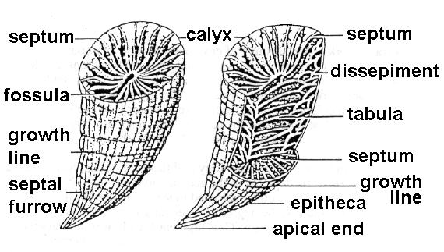
QUESTION 12:
SOLITARY RUGOSE CORALS

Examine these horn corals and Calceola. Note that they are not straight cones nor perfectly cylindrical. They also had a little trap door (operculum) which usually falls apart from the horn-like part after death.

What does the flattened shape indicate about their life position (12)?
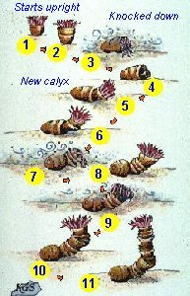

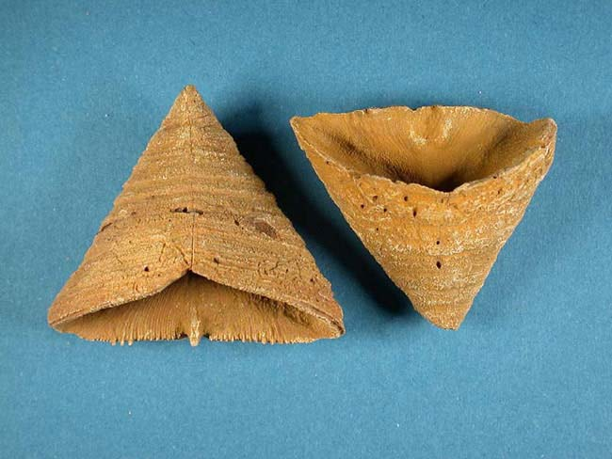
QUESTION 13:
SOLITARY RUGOSE CORALS

What information about the Earth’s rate of rotation was confirmed by Scrutton and Hipkin (1973) in their study of the growth bands of Devonian rugose corals (13a)?

In what climatic conditions must the rugose corals have grown to provide sufficient evidence to support their conclusion (13b) ?

(The text for this question, as well as for questions 16 and 17, is on WebCT.)

QUESTION 14:
COLONIAL RUGOSE CORALS

Select one example of a colonial rugose coral in the collection and describe its colony form as phaceloid, cerioid, astreoid, aphroid, coenostoid or meandroid.

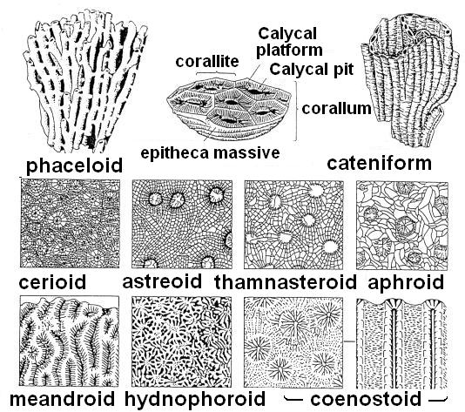
QUESTION 15:
CHEILOSTOME BRYOZOANS

Examine the habit of the colony in the following Recent bryozoans Retepora, Cellepora, Membranipora, Escara.

Find one example of each of the following growth habits: encrusting (15a), ramose ( = branching) (15b), platy or bladed (15c).
QUESTION 18:
TREPOSTOME BRYOZOANS

Trepostomes have partitions within and between their tubular housings that resemble those of certain corals.

With which order of coral (TABULATA, RUGOSA, SCLERACTINIA) are their skeletons most likely to be confused (18)?
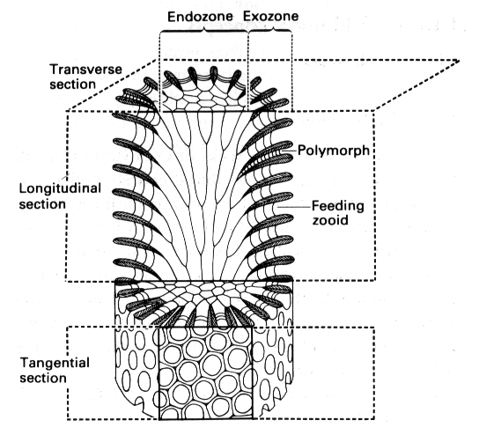

QUESTION 19a:

BRYOZOANS vs. other reef builders

Compare these specimens of Hallopora and Pocillopora.

Indicate which genus is the trepostome bryozoan (diagram to the left indicates a typical structure).

What skeletal feature identifies the other genus as either a tabulate coral, a scleractinian coral or a stromatoporoid (poriferan)?
QUESTION 19b:

BRYOZOANS vs. other reef builders

Compare these specimens of Constellaria and the second specimen, unlabelled (with a thin section).
- Indicate which genus is the trepostome bryozoan (diagram to the left indicates a typical internal structure).

- What distinctive characteristic identifies the other specimen as either a tabulate coral, a scleractinian coral or a stromatoporoid (poriferan).

QUESTION 19c:

BRYOZOANS vs. other reef builders

Compare these specimens of Prasopora and Favosites.

Hint: one of these two genera also appeared in Question 8 of this laboratory exercise.

Indicate which genus is the trepostome bryozoan. (The diagram to the left indicates a typical internal structure.)

How can you identify the other genus as a tabulate coral, a scleractinian coral or a stromatoporoid (poriferan)?

If distinctive features are lacking on the specimens, explain what you might look for in either a transverse or a longitudinal section.
OBSERVATION ONLY:
FENESTRATE BRYOZOANS

Fenestrate bryozoans built lacy sheets pierced with large openings. The smaller zooecia were all facing the same way, on one side of the sheet.

Examine the specimens provided under the stereomicroscope. Look at the surface of the sheets between the larger openings. Can you see the smaller pores which are the openings of the zooecia?

NO DRAWING REQUIRED.

QUESTION 20:
FENESTRATE BRYOZOANS

Archimedes is a particularly distinctive genus because its sheet is coiled into a helical crew.

Does this necessarily make it a good index fossil, or does it fail other important criteria for a good biostratigraphic marker (20)?

