Proposal for using the locality of Levis as an example of an Ordovician slope sequence, brought against undisturbed sequences of the lowlands by the early phase of Appalachian mountain building (Taconic orogeny):

Background: During the Cambrian and Ordovician, the eastern margin of Laurentia was flooded by a continental sea which left fossiliferous sedimentary rocks in southern Quebec, Ontario and the northeastern U.S. Tens to hundreds of kilometers southeast of Quebec City, the shallow sea at the margin of the continent gave way to a deepwater slope. During the late Ordovician, as the Appalachians started to form, Cambrian and Ordovician rocks deposited on this slope were folded and transported northwestward as thick sheets.

This is spectacularly shown across from Quebec City in the cliffs of Levis and at Anse Maranda, on Ile d'Orleans. Between Quebec and Levis, a major fault (Logan's line) running along much of the St. Lawrence separates the flat-lying sedimentary strata of the St. Lawrence Lowlands from the folded rocks of deeper offshore Lower Ordovician marine strata.

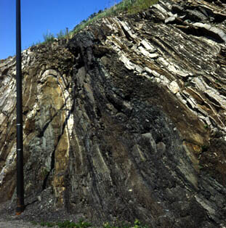
Folded slope sequence along Cote Frechette, Levis.

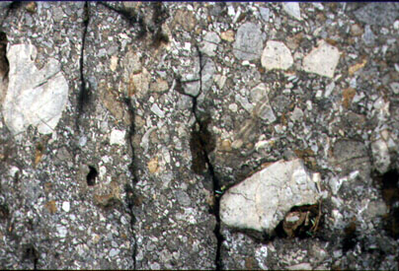
Close up of conglomerate (a bed of shallow-water pebbles swept onto the continental slope).

The slope strata, exposed in the Pointe-de-Levy nappe, are strikingly different from the shallow-water sequence of the St. Lawrence Lowlands. Fine-grained material eroded from the continents was swept far offshore and settled as beds of banded green, yellow and gray shales. The shales, often rich in graptolites, represent the normal deepwater sedimentation. They alternate with lighter-coloured beds of shallow-water debris that were swept over the edge of the shelf as submarine avalanches of grains and rocks, triggered by storms or earthquakes.

Graptolites were diversifying during the Ordovician and their fossils are common in deepwater shales. Many graptolite species, described for the first time from the Levis shales in the 19th century, are still used to recognize Ordovician strata in North America and Europe. The trilobites identified in the rock debris confirm that many were eroded from calcareous-algal reefs that had built up at the shelf edge.

The display can combine specimens of graptolite and trilobites with slabs of turbidite, grainstone, conglomerate and reef blocks to show the wide range of sedimentary rock types exposed in Levis.

