QUESTION 1.

Nautilus, a living nautiloid

Orient the shell in its living position and draw a cross section through the plane of the siphuncle of the shell and label the following: septum, septal neck, septal foramina (i.e. openings), position of the siphuncle (you can “dot it in” since the connecting rings are not preserved), living chamber, initial chamber (1).

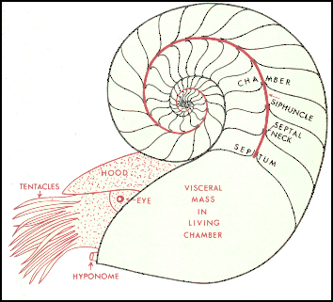
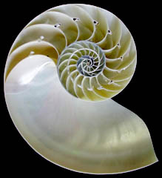

Question 2.

Nautilus, a living nautiloid, is the only genus left of a subclass that left nearly 1,000 genera in the fossil record.

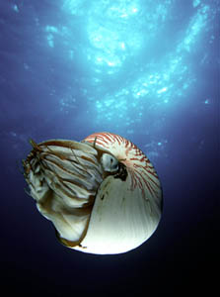
Note the striped protective colouring on the exterior of the immature (juvenile) smaller specimens.

How does the colour pattern change in the mature animal (2a)?

What may be the adaptive value of the pattern (2b)?

Why should the pattern change as the animal matures (2c)?
OBSERVATION

Nautiloid fossils

The septa of nautiloids are simple concave plates. This is best seen in fossil specimens in which the chambers have been filled with sediment and then fell apart.

Examine the specimen that shows these separated chambers. Is it an internal/external mold or cast?
Question 3.

Nautilus

The "pearly" aragonite inner layer of Nautilus is only visible where the dull outer layer has worn off. The outer layer is commonly removed from specimens sold in shops to enhance their appearance. Examine the specimen from which the outer layer has been stripped away.

Was a similar layer present on the inside of some bivalves? What was its name and mineralogy (3)?
QUESTION 4.

FOSSIL NAUTILOIDS

Examine the silicified and polished specimens of Armenoceras and other orthoconid (i.e. straight-shelled) nautiloids. Draw a longitudinal section showing the outer wall, septa, septal necks, connecting rings and deposits in the greatly enlarged siphuncle (4).

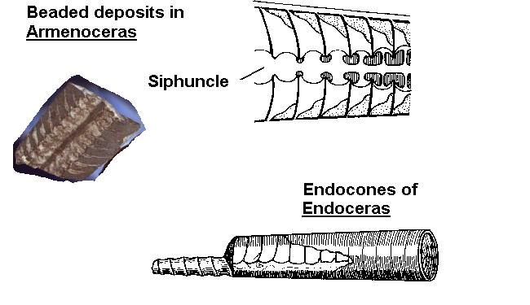
Observation

Fossil nautiloids

Examine specimens (e.g., Actinoceras) and look for evidence of ring-like siphuncular deposits which may have helped stabilize the position of the shell.

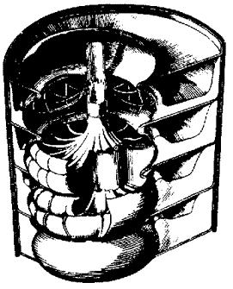
Some specimens show "inflated" siphuncles but no apparent deposits in them. We do not know if they were dissolved during the life or after the death of the animal, or were simply absent.
Question 5a.

FOSSIL NAUTILOIDS

Endoceras was a large straight nautiloid with a wide central opening in a massive siphuncle. What type of deposits were secreted to weight its shell (5a)?

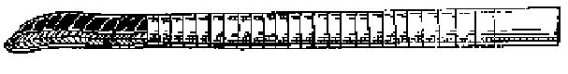
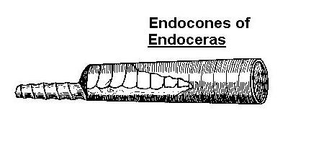
Question 5b.

FOSSIL NAUTILOIDS

Paleozoic nautiloids have a variety of forms in addition to coiled and straight. The position of all nautiloids depended on the vertical alignment of their centres of gravity (in the body chamber) and of buoyancy (in the gas-filled shell). What would have been the living position of orthoconic (i.e. straight, uncoiled) nautiloids without the presence of siphuncular deposits (5b)?
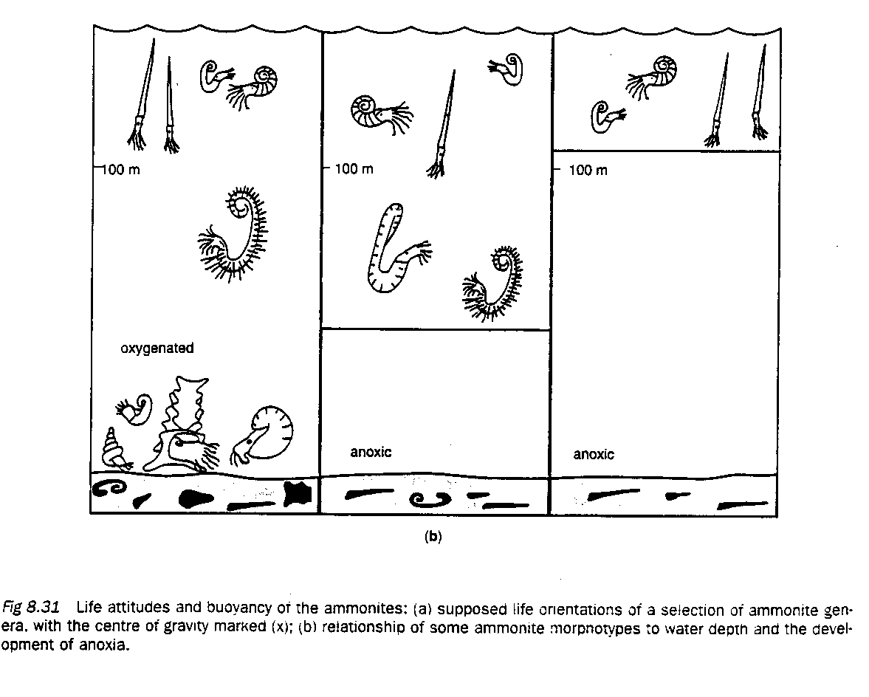
Question 5c.

FOSSIL NAUTILOIDS

Examine the plaster cast of Winnipegoceras and compare it to the reconstructions of life positions shown for various shapes of nautiloid shells. Draw a sketch to show how the distribution of chambers and body chamber might have oriented its shell in the water. Assume that no siphuncular deposits were present.

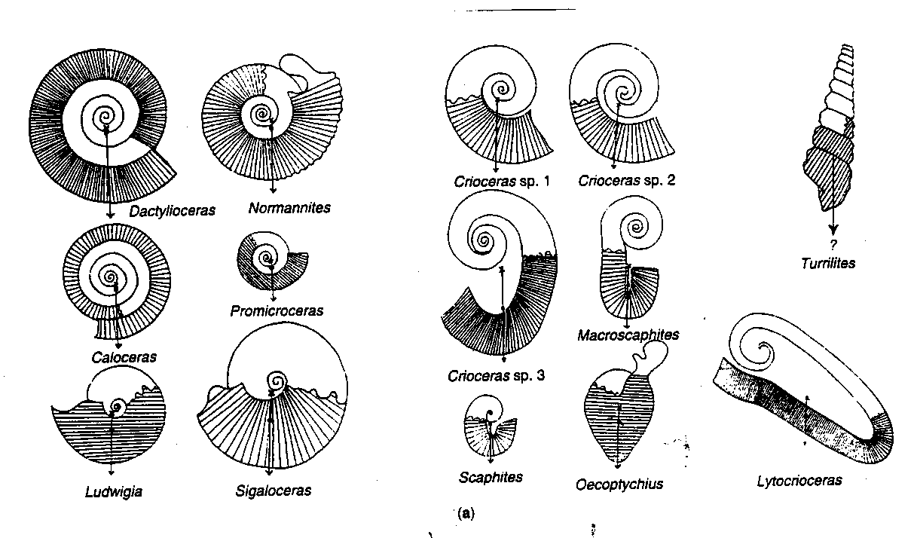
Question 6a, 6b.

Ammonoids of three major suture types succeed each other in time, from the late Paleozoic through
the Mesozoic.
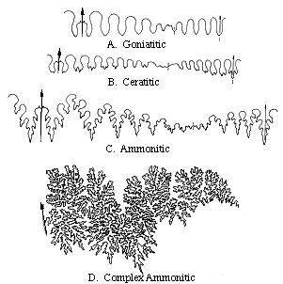
One standard way of drawing the suture (shown on left) is to show one half of the pattern, to the right of the venter. The arrow points towards the aperture of the shell.

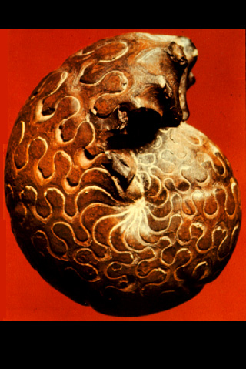
How would you describe the suture of Goniatites (a middle Paleozoic ammonoid). For example, are there well defined saddles and lobes well? Are the saddles wider, narrower, smoother or more ornamented than the lobes (6a)?

Make a sketch of the side view of one of the genera of goniatites (left) from the collection, clearly showing the sutures (6b).

Questions 6c-d.
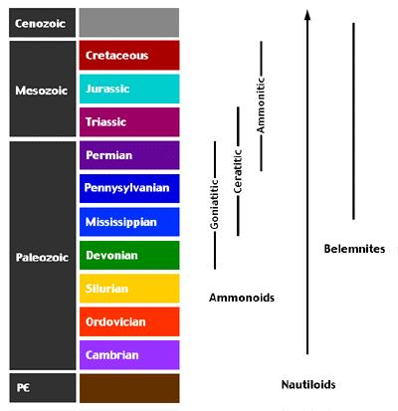
Ammonoids of three major suture types succeed each other in time, from the late Paleozoic through
the Mesozoic.

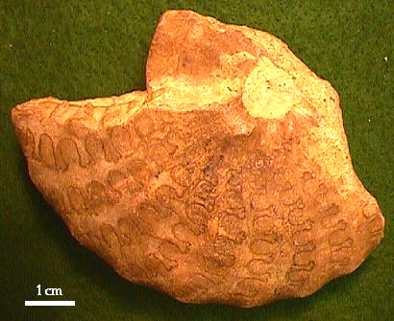

How has the pattern changed, from Goniatites (middle Paleozoic) to Ceratites (shown to the left) during the late Paleozoic (6c)?

Part of the ceratitic suture lines are intricately folded and the other is a simple fold. What names are given to these different parts of the suture (6d)?
Question 6e.

Ammonoids of three major suture types succeed each other in time, from the late Paleozoic through
the Mesozoic.
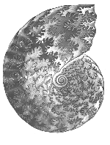

How is the suture pattern further modified, from Ceratites to Ammonites (6e)?

QUESTION 7.

AMMONOID CHAMBERS

Examine the chambers of ammonites that have been broken apart and where the septal face can be seen.

What preservation process (permineralization, internal or external mold or cast) gave rise to these fossils (7a)? What information is lost about the shell structure and composition from such fossils (7b)?

Note how complex a suture is produced by the progressively more intricate folding of the septum as it reaches the outer wall.
Question 8.

AMMONOIDS

Examine the specimens of ammonites that have been cut and polished.

Draw a simple cross section showing one of them in the living position (8a), and label the living chamber and the siphuncle.

Note the thinness of the walls, the shape of the septa and the position of the siphuncle. How do these characteristics identify any one these specimens as an ammonoid rather than a coiled nautiloid (8b)?

Are the septa visible on the outside of the shell and identical to their trace on the polished side (8b)?

Why is it not possible to see the siphuncle in all specimens (8c)?

Why is the living chamber generally filled with a different material than the earlier chambers (8d)?
QUESTION 9.

HETEROMORPHS

Match each specimen to one of the following descriptions

- coiled like a gastropod
- no coiling, 2 sharp bends
- open coil
- uncoiled from original tight coil then bent back at maturity

Hamites (9a)

Turrilites or Plesioturrilites (9b)

Scaphites – (9c)

Spiroceras – (9d)

Which one of these ammonoids would you be most likely to confuse with a gastropod (9e)? How could you tell them apart in cross section (9f)?
Question 9 (pictures).

AMMONOIDS - Heteromorphs

Use these diagrams to match the genera to the coiling patterns.

Scaphites Hamites
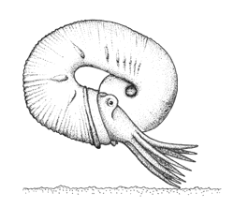
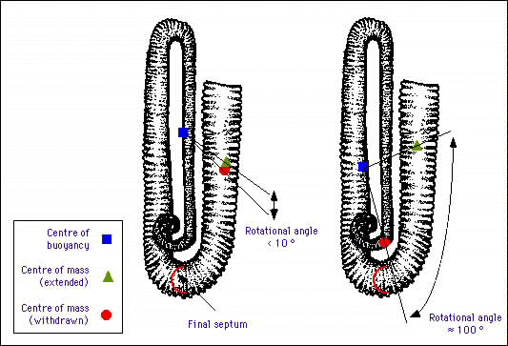
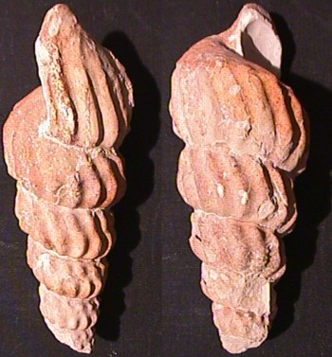
Turrilites and Plesioturrilites (left), Spiroceras (right)
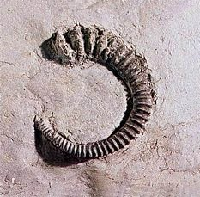

Question 10.

AMMONOIDS - Heteromorphs

Although nautiloids and goniatites commonly have smooth shells, ceratites and ammonites have shells ornamented with knobs, ribs, and keels. What explanation(s) have been given for the adaptive values of these features (10a)?

The descendants of these animals (Nautilus and the coeloids) have a well developed visual system. Paleontologists have speculated that the ornamentation may have played a role in mate selection. Some researchers also think that these features may have helped in stabilizing the shell position during swimming. There is no definitive answer to this question.

Examine of the following ammonites showing surface ornaments. Why can’t you see their sutures throughout the ribs (10b)?

Question 11.

AMMONOIDS

Although nautiloids and goniatites commonly have smooth shells, ceratites and ammonites have shells
ornamented with knobs, ribs, and keels. Their adaptive function (ensuring species recognition during mate selection, or improving stability in the water column) is debated. It has been suggested that faster swimmers had smoother shells.

Match the specimens to their description (see pictures next page)

- transverse ridges, all whorls visible fron the side
- transverse ridges, keel on outer edge.
- sharp nodes from which 3 ridges branch outward from the side.
- smooth, thin, discus-shaped shell.
- coarse ribs and nodes

Dactylioceras (11a)
Amaltheus (11b) OR Arnioceras (11b)
Scaphites (11c)
Placenticeras (11d), Acanthoceras (11e)
Questions 11a-11e.

AMMONOIDS

Although nautiloids and goniatites commonly have smooth shells, ceratites and ammonites have shells ornamented with knobs, ribs, and keels.

Match each of the specimens with one of the following descriptions of ornamentation:
- ridges, keel on outer edge
- transverse ridges, all whorls visible fron the side
- sharp nodes from which 3 ridges branch outward from the side.
- coarse ribs and nodes
- smooth, thin, discus-shaped shell

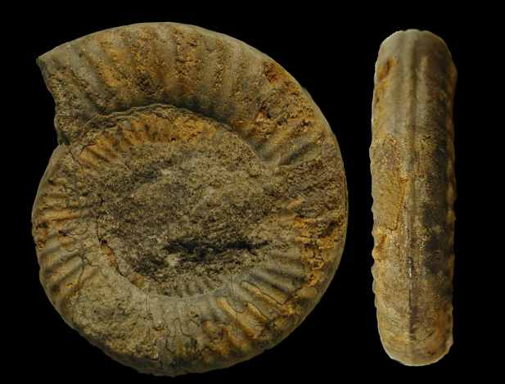
1st row: Acanthoceras - Amaltheus - Arnioceras -
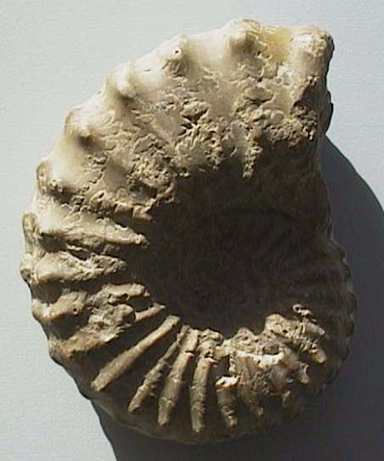
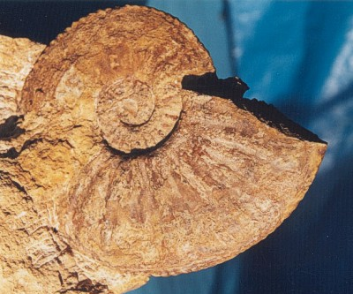

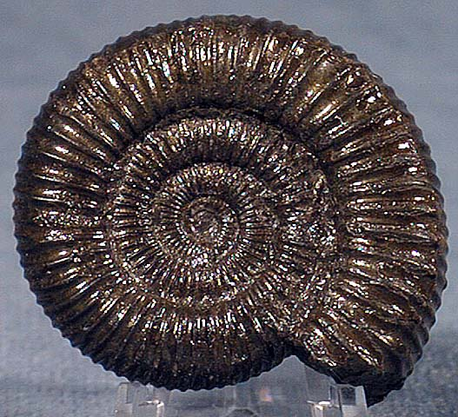
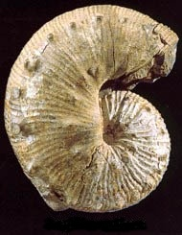
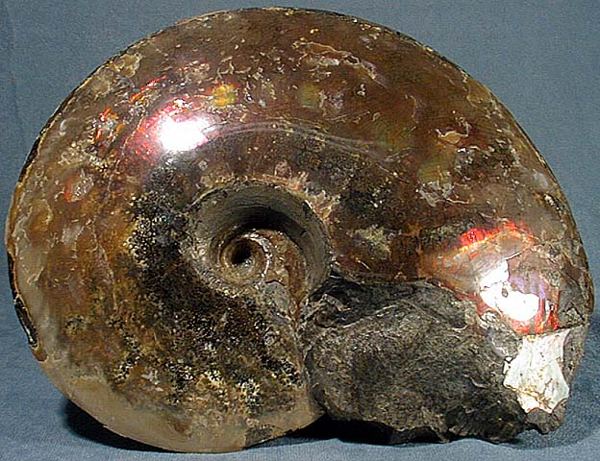
2nd row: Dactylioceras, Placenticeras Scaphites,
Question 12.

COELOIDS

Coeloids are cephalopods with a much reduced shell, covered by soft parts of the animal. Their Recent relatives include the octopus, the squid and the argonaut.
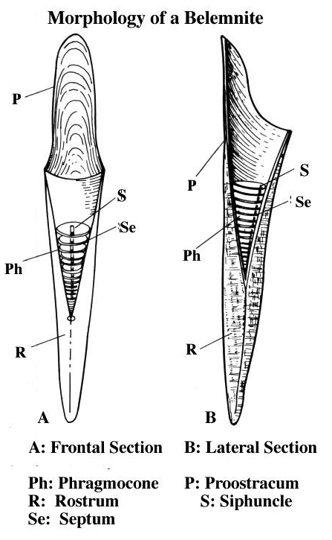
BELEMNITES

Examine the fragments of large belemnites that show the chambered shell and its position in the guard. Examine and sketch (12) the specimen from the Solenhofen limestone (a fine-grained limestone famous for its fossilized Archaeopteryx). The excellent preservation shows the guard (labelled here into its parts: the chambered phragmocone + solid rostrum), chambers, and even the pen (pro-ostracum) which supported the front of the animal but is very rarely preserved.
QUESTION 13.

Argonaut, the "paper Nautilus".
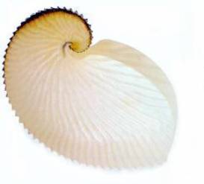
"Argonauts" are a group of extant cephalopods. Examine their paper-thin shell and read the following description of argonauts. Is their shell homologous with the shell of Nautilus(13a) What is its purpose (13b)?

An unusual feature of argonauts is the secreted shell that functions as a brood chamber. The "shell" is not homologous with the true molluscan shell as evidenced by its unique site of formation: the dorsal arms of the female rather than the internal shell sac as in other coleoids. Naef (1921, 1923) noted the remarkable resemblance of the argonaut shell to the shells of some of the abundant Cretaceous ammonoids and suggested that the argonaut shell evolved in the following way: ancestral argonauts occupied empty ammonoid shells during the late Cretaceous. [Occupancy of molluscan shells by octopodids is common in the present day.] The octopod evolved glandular structures on the arms to repair the shell of the ammonoids after the latter had become extinct at the end of the Cretaceous. Eventually, the ammonoid shell was completely replaced by a secreted structure whose shape had been evolutionarily molded by the ammonoid shell. However, as pointed out by Young et al. (1998), a gap of about 40 million years exists between extinction of ammonoids and the earliest fossil record of an argonaut and they suggest that the mold for the shell was from some other type of mollusc and that the resemblance to ammonoids is coincidental. The origin of the argonaut shell is a challenging problem and has important implications for understanding the relationships among groups of the Argonautoidea (Young, et al., 1998).

