QUESTION 1 (choose either this one or Ogygia):
Label as many parts as possible on this drawing of Ogygopsis.
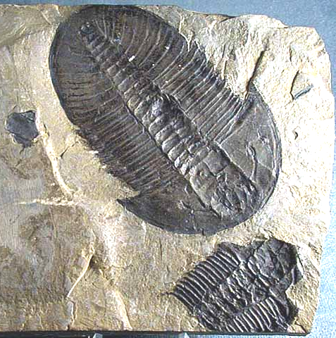
QUESTION 1 (choose either this one or Ogygopsis):
Label as many parts as possible on this drawing of Ogygia.

