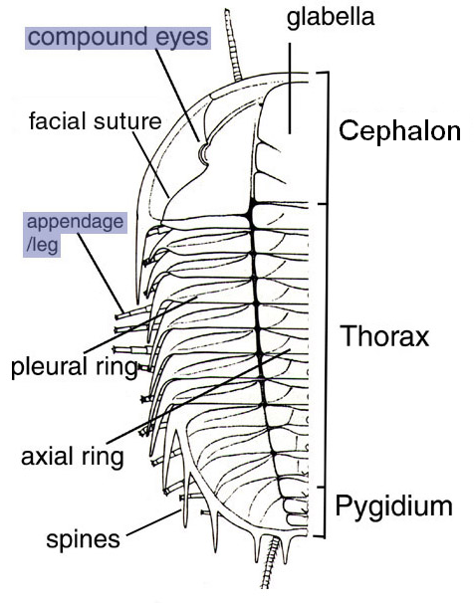QUESTION1: diagrams

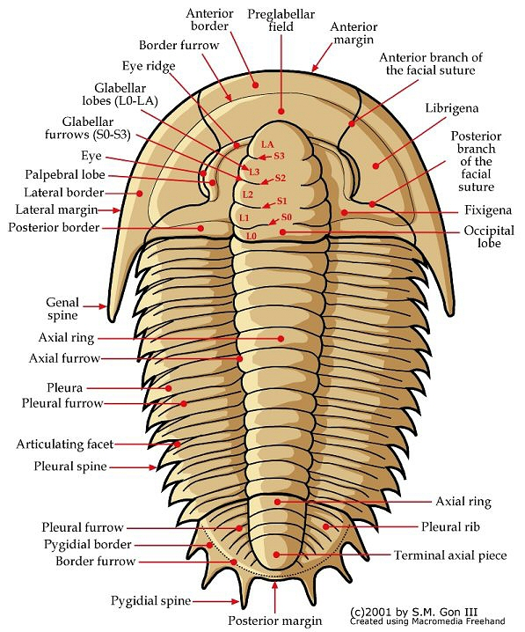
Question 1: Ogygia
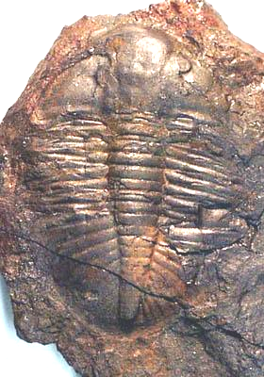

Question 1: Ogygoposis
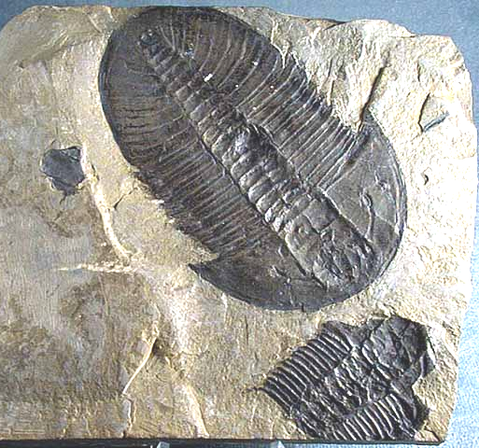
Question 1:

Choose a drawing of a specimen of one of the following genera: Ogygopsis (below, left) Ogygia (below, right).
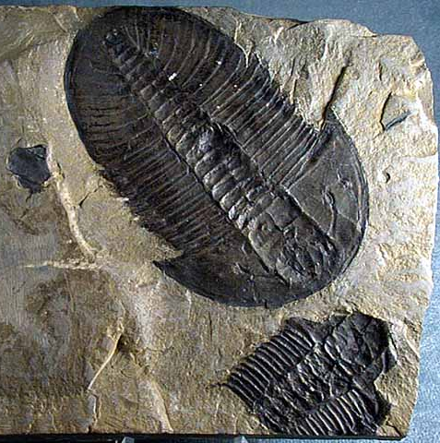
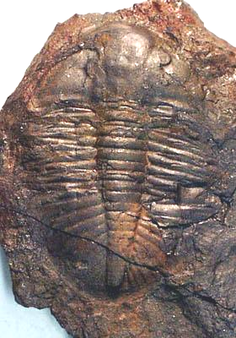

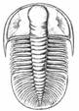

Label on it as many of the identifiable features as you can find (1). Make sure you look for: glabella, cephalon, pygidium, thorax, axial lobe, pleural lobes, facial suture, free and fixed cheeks, glabellar segments, genal spines, eyes (but label them only if they are distinct).

Observation only:
Examine the actual fossils of Ogygopsis and Ogygia. Are there clearly missing parts on the specimens? What are they?
Question 2:

The cephalon of trilobites seemed to have been formed primitively by the fusion of several segments and the specialization of certain pair of appendages.

Examine the plaster restorations of Triarthrus from the Middle Ordovician Utica shale. How many segments make up the cephalon (2a)?

Does your answer to 2a make sense when you compare it to the number of glabellar furrows (2b)? Sketch the glabella with its furrows to justify your answer.

What type and how many pairs of appendages are present on the cephalon of Triarthrus (2c)? (Note that this number should correspond exactly to the number of segments found in 2a.)

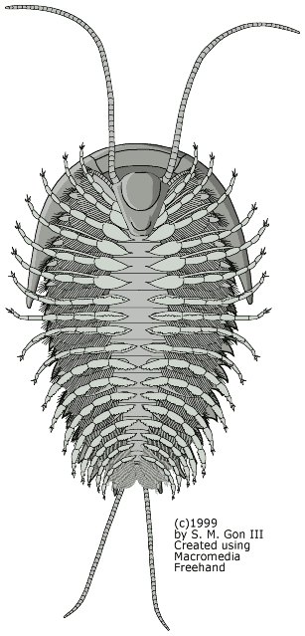
Remember: the appendages of arthropods are specialized to fulfill different functions. Examples of specialized appendages are: antennae, feeding palps, and jointed legs with their feathery breathing gills.

Observation only:

(No written answer required…)

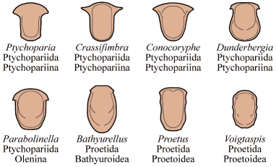
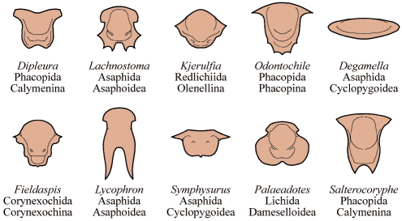
The hypostome was a calcified plate in the mouth area, on the underside of the exoskeleton.

Look for the hypostome on the plaster restoration of the underside of Triarthrus. Is this an example of a conterminant hypostome (box on the left) or more specialized natant hypostome (box on the right) ?
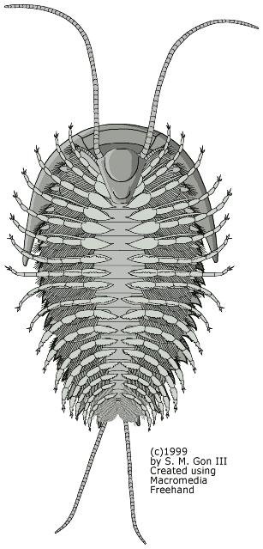
Reminder: a conterminant hypostome is attached to the rostral plate, whereas a natant hypostome is unattached (as on the left).

Do you know of extant groups of animals where the feeding parts show many different shapes, and are adapted to specific foods? Are some of these animals in the same phylum as trilobites?
Question 3:

ISOTELUS

Note: the specimen for question 3a is missing. Skip it.

Examine the partial cast showing appendages. On what part of the skeleton (cephalon, thorax or pygidium) are the appendages located (3b)?

What distinguishes the head from the tail on specimen O339.2 (3c)? Give at least two characteristics.

What type of observations would help determine whether the smaller specimen of Isotelus is an adult of a different species, or a juvenile form of the larger specimens (3d)?

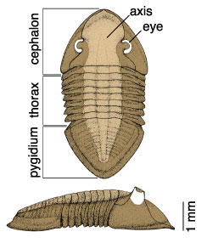
Left: a generalized drawing for the genus Isotelus, not necessarily for the same species as the specimen in our collection.
Question 4a:

Preservation

Trilobite exoskeletons came apart easily, during or following molting or after the death of the animal, because they were joined by soft tissue, flexible but biodegradable.

Sketch and identify at least two of the most common body parts present in the Glossopleura-rich specimen O224 (4a)?

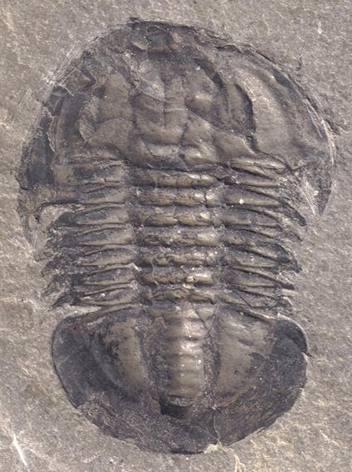
Question 4b:

Examine also the larger limestone specimen, rich in Isotelus fragments (whole morphology shown below). What parts of its exoskeleton appear as the folded and undulating thin fragments in this rock (4b)?

Question 4c:

What is the evidence that this specimen is a mold of the inner surface of a trilobite pygidium (tail), and not a cast of its outer surface (4c)?

To answer this question:
i) make a sketch of the exoskeleton seen in a transverse section (perpendicular to the long axis of the animal). Do not forget the doublure of the exoskeleton. Then, fill in the area that would take a mold of the inner surface.

ii) do a separate drawing to show a mold of the outer surface AND the cast that would result. What impression would the doublure leave?

iii) Compare your drawing to the specimen, and look for evidence of the doublure on the specimen.

Question 5:

Enrolment in trilobites

Examine enrolled specimens of the common Ordovician trilobite Flexicalymene (below, left), Homalonatus (Devonian) and Calymene (Silurian genus, below right).
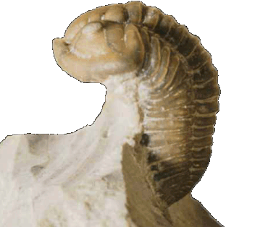
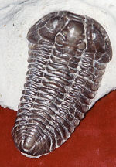

What part of their body were they protecting by enrolment (5a)? Why not protect their eyes instead (5b)?

QUESTION 6:

One noteworthy aspect of the overall morphology of Cambrian trilobites is the relative size and shape of their head and tail. There was a tendency in some lineages to evolve towards heads and tails that matched closely and could therefore protect better an enrolled trilobite.

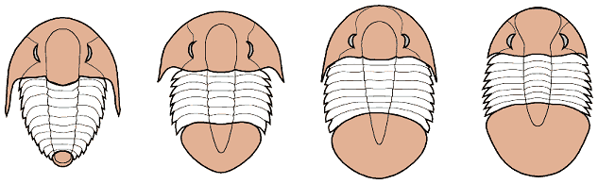
Can you find, among the specimens displayed here, examples of two trilobite genera that are either macropygous or isopygous, and two more that are clearly micropygous (6)?

First two, on the left - micropygous: tail is smaller than head.
Third from left - isopygous: tail is about same size as head.
Right - macropygous: tail is larger than head.

Question 7:

To see or not to see...

The eyes of trilobites tell us something about their mode of life. In the earliest trilobites (the order Redlichiida, e.g. Olenellus) the nature of the eye is obscure and the eye area is usually preserved only as a hole in the cephalon.

In later trilobites the eyes are definitely compound like those of a fly and of two types: holochroal, with a single outer covering of the many lenses, and schizochroal, with opaque tissue separating the lenses.
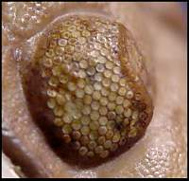
The holochroal type (left) is more ancient. Aulacopleura and Albertella have this type of eye. Unfortunately our specimens do not clearly show the lenses.

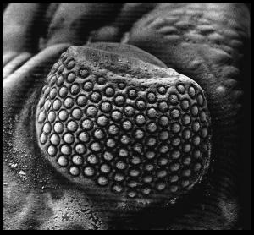
We have well preserved examples of schizochroal eyes (right), on specimens of Phacops.

Draw a closeup view of a cephalon to show the location and structure of the schizochroal eyes on Phacops (7).
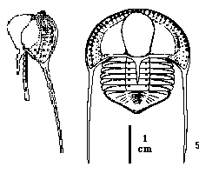
Question 8:

Some trilobites had raised eyes or were without eyes and therefore blind. Some of these are thought to have lived buried in bottom sediment.

Draw the cephalon of the blind Ordovician trilobite Cryptolithus (8a), a genus common in local limestones of southern Quebec and Ontario.

What may have been the function of the pits within the brim (i.e. the flat margin) surrounding the cephalon (8b)?
Question 9.

Examine and draw a specimen of Aqnostus (9a) from any of those provided. Note that the cephalon and pygidium have separated in almost all specimens. Locate a separated pygidium and cephalon for your drawing, or choose a specimen preserved whole.
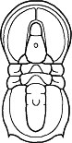
This genus, member of the order Agnostida, is typical of the Middle and Late Cambrian. Would you describe it as isopygous, macropygous or micropygous (9b)? [See question 6 for a definition of these terms…]

What type of eyes did this trilobite have (9c)?

What was its mode of life: benthic or planktonic (9c)?

How can it be inferred, i.e. is it possible to deduce this from the morphology of the fossil or from the distribution of agnostid fossils in sedimentary rocks (9d)? (We will discuss this in class on Monday.)
QUESTION 10:

Sketch Eoharpes or Harpes from a specimen in the collection (10a). A representative drawing of the whole exoskeleton is shown below.
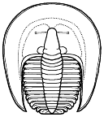
The eyes of these genera were much reduced, often to 2 or 3 lenses only, according to LEVIN. How would this relate to the lifestyle deduced from its skeleton(10b)?

[This point will be discussed on Monday.]
QUESTION 11:

Examine the trace fossils attributed to trilobites.

How are they thought to have been produced (11a)? Can you recognize impressions of specific parts of the exoskeleton?

Have traces similar to those left by Cambrian trilobites been found prior to the Paleozoic (11b)?

[These questions will be addressed in the Monday lecture].
Observation only

THE BURGESS SHALE FAUNA

We have a small suite of fossils from the Burgess Shale.

Examine at least three specimens and look for differences in their mode of preservation (12). Note the genus name of the fossils and your own observations.

Hints: are there differences in color suggesting replacement by various minerals rather than preservation as a carbon film? Are all these fossils perfectly flat (as would be expected from soft-bodied animals compressed by the weight of sediments) or do some show relief (sign of rigid exoskeletons)?

