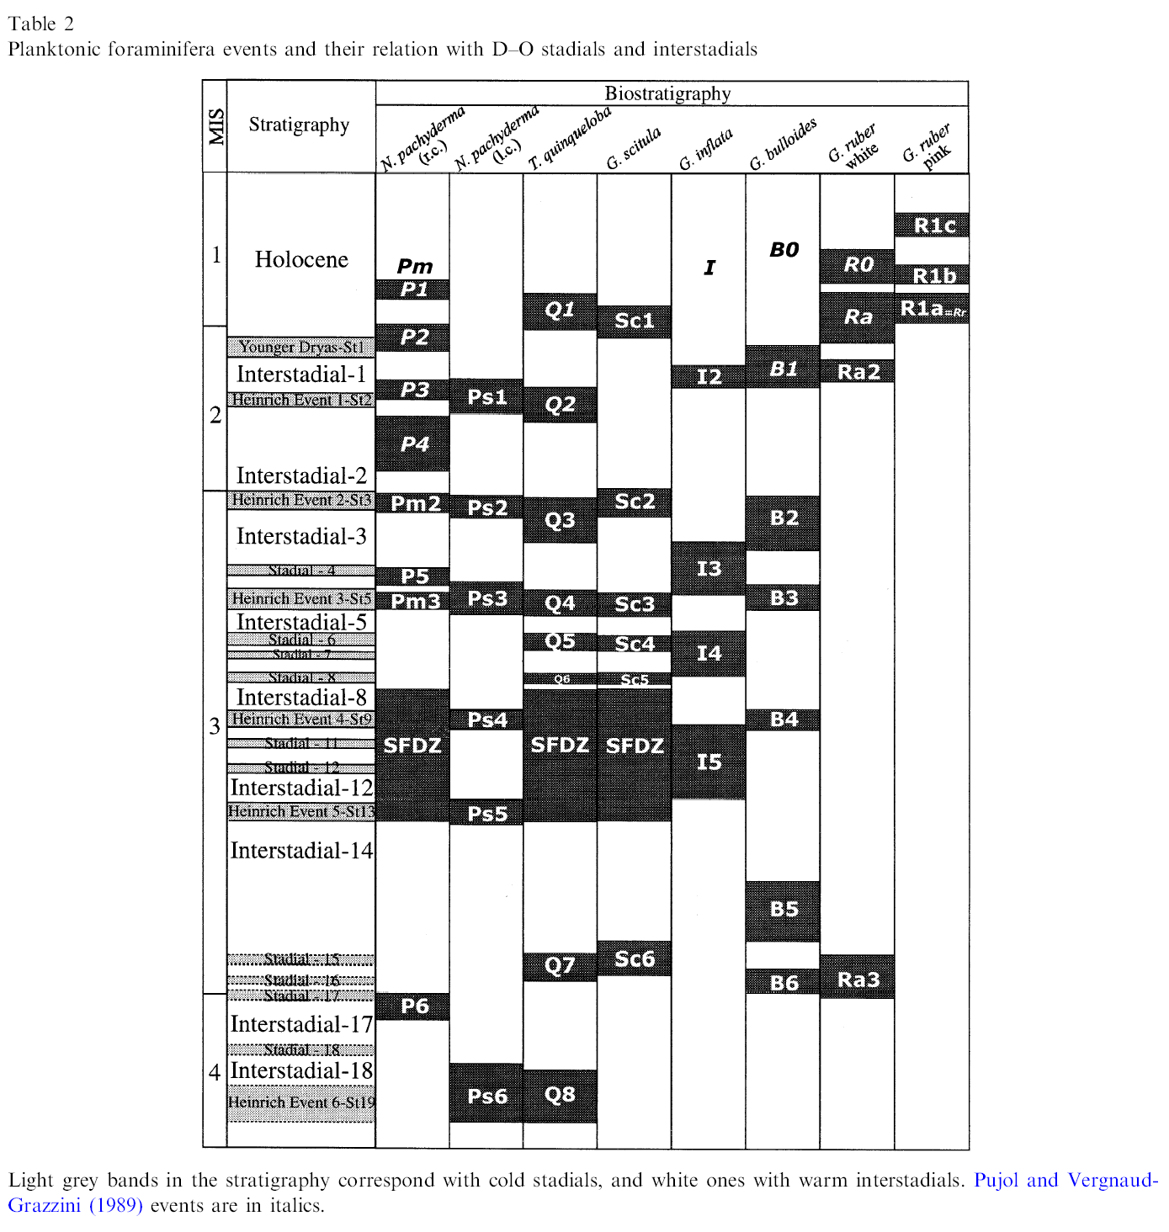
Table 2 from "Western Mediterranean planktonic foraminifera events and millennial climatic variability during the last 70 kyr", M. Perez-Folgado et al. / Marine Micropaleontology 907 (2002) pp. 1-22.

Next to N. pachyderma, "r.c." stands for right-coiling, "l.c." for left-coiling.
Which type is found mostly in intervals corresponding to Heinrich events?

The German oceanographer Hartmut Heinrich discovered six separate layers of small stones dropped by icebergs off the coast of France. The same six events are found over much of the North Atlantic seafloor. They record great waves of icebergs (triggered by caving at the edge of polar ice caps during global warming episodes) known as Heinrich events. C¹⁴ dating of fossils from these sediments has determined that these events occurred during the recent Ice Age at intervals of about 10,000 to 50,000 years.

