McGill University, Department of Earth & Planetary Sciences
Invertebrate Paleontology EPSC 334

Laboratory 3: Precambrian animal life and the phylum PORIFERA

Precambrian trace fossils: stromatolites

Examine the layered specimen collected from the Ediacara hills, in Australia. Its interpretation is tricky. Similar rocks are sometimes simply described as algal rock, or algal growth. Processes of preservation give rise to a range of microstructures which can be misinterpreted as evidence of biological structures or activity. What type of evidence do Westall et al. (1999) propose to recognize ancient bacterial activity (1a)? Are the layered structures preserved in this specimen, and in many stromatolites examples of body fossils, trace fossils or chemical fossils (1b)? (Briefly justify your answer.)

Brian Jones (U. Alberta) has examined stromatolites and microbial structures forming in a wide range of Recent settings. What other type of organisms besides prokaryotic blue-green algae were involved in the formation of stromatolites described by Jones et al. (1997) (1c)?

Go upstairs to the Dawson Gallery and have a look at the large case containing a cast of the oldest Australian stromatolites. Stromatolites develop diverse shapes and these are given binomial Genus species names. What conditions would they have to meet to be good index fossils for specific intervals of Precambrian time (1d)?

Precambrian macrofossils: the Ediacaran (or Vendian) fauna

In 1946 the first Precambrian macrofossils were discovered in the Ediacara Hills of South Australia. Precambrian rocks had been so far thought to be entirely devoid of life, and that time period was often referred to as the Azoic eon (i.e. “without life”).

Note the nature of the sedimentary rock in which Ediacaran impressions are preserved: is it limestone, shale or sandstone (2a)? Considering the texture of the sedimentary rock in which many Ediacaran impressions are preserved, is it likely that these fossils were soft bodied (2b)?

What role could bacterial mats have played in the preservation of Ediacaran organisms (2c)?
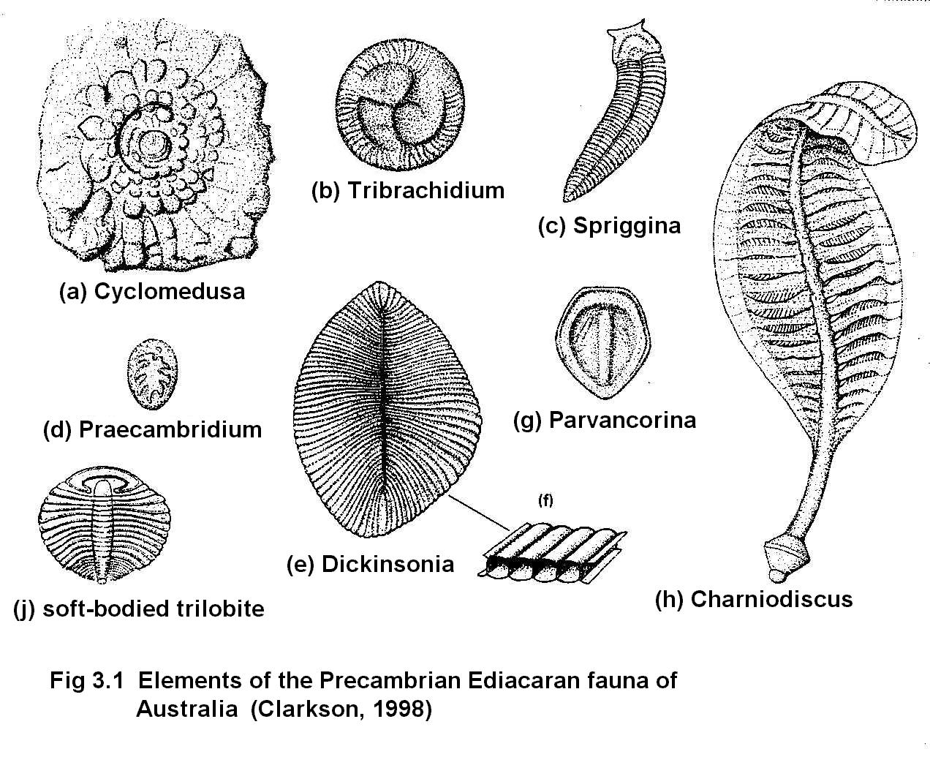
Even where the sedimentary rock is much finer-grained, the impressions left by many Ediacaran/Vendian fossils suggest "quilted" surface patterns. What did Seilacher mean by the term “quilted” when he proposed a radically different body plan for Ediacaran animals (2d)?

Among the drawings of Ediacarans (left), find at least one example each of a radial and a bilateral body symmetry (3)?

PHYLUM Porifera

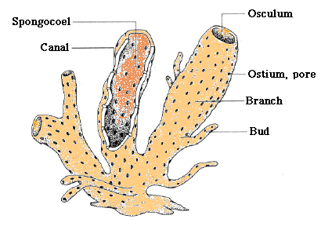
The basic sponge consists of a jar-shaped structure which filters micro-organisms from the water as it passes through the walls and out the orifice. In nearly all sponges the micro-organisms are trapped in minute chambers within the wall that are lined with collar cells (choanocytes). Each of these cells is equipped with a flagellum which by its motion creates the current of water that brings food to the organism. Incurrent canal systems bring water to the chambers from outside and the excurrent canal(s) discharge it via the central cavity or spongocoel. through the osculum (aperture).
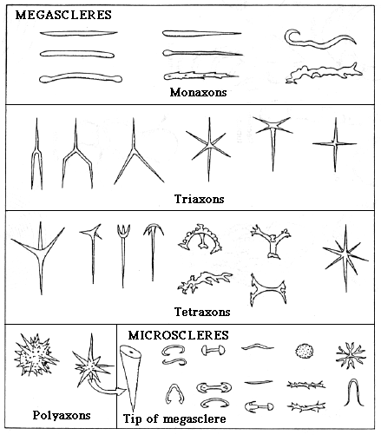
The structural support of the sponge body is secreted in the jelly-like middle layer by amoeboid cells: spongocytes and sclerocytes. The sponge skeleton is composed of small individual elements called spicules which may be composed of spongin (a protein), silica, or calcite. A few living sponges also secrete a massive, non-spicular, basal skeleton of calcite or aragonite (two crystalline forms of CaCO₃), and several groups of fossil sponges (stromatoporoids. archaeocyathids) also formed resistant. non-spicular skeletons. Simple spicules are composed of one to many rays extending from a central point and are not connected to each other so that they fall apart after the death of the soft tissue in which they were embedded. Some spicules fuse with their neighbours at their tips to form a rigid framework. Others are knobby and interlock to preserve the shape of the sponge when the soft tissue decays.
Classification - Modern sponges are divided into 4 classes: DEMOSPONGIA, CALCAREA (or CALCISPONGIA), HEXACTINELLIDA (or HYALOSPONGIA) and ARCHAEOCYATHIDA

Class DEMOSPONGIA

This is by far the largest class of living sponges. All are of leucon grade. The skeleton is composed of silica or spongin. The spongin group, which constitute the order Keratosa, do not have a fossil record.

Examine the specimens of modern dried spongin sponges. Find one and examine its wall structure. Describe features that identify it as being of the leucon grade (4a). Draw it, label its ostia and osculum (or oscula) and indicate with arrows the path of water in or out of them (4b). Is this body plan an example of radial or bilateral symmetry (4c)?

Tethya - Examine the specimens of this small spherical sponge, recovered from post-glacial clays of the Montreal area. Draw some of the spicules of this sponge using the microscope (5).

LITHISTIDS are a group of Demosponges charcterized by lumpy spicules that interlock to form a rigid framework and are therefore commonly preserved as fossils. They range in age from Cambrian to Recent but were most abundant in the Cretaceous.

In the Cretaceous Chalk of the English Channel these sponges commonly form the nucleus around which flint nodules have formed. Examine the collection of flints from the Chalk and note the sponge fossils. What was the likely origin of the mineral matter that hardened into flint (6)?

Examine and draw a sketch of the cross section of the Cretaceous lithistid Siphonia (7a). Draw small arrows to show the path of the water through the canals.Why isn't the larger osculum visible on the vertical section through this specimen (7b)?

Much older lithistids are found in Silurian limestones in Ontario where they are associated with light-coloured flint known as chert. Astylospongia, Hindia, and Microspongia are typical of these sponges. Examine the specimens and draw one of them (8a). Is there any evidence of the type of canal system or the grade (ascon, sycon, leucon) of the sponge (8b)?

Class HEXACTINELLIDA

The organization of the cells (they have several nuclei) in this group of sponges is so different from that of the other members of the phylum that they are considered by some biologists to be a separate subphylum. They are also known as the glass sponges or hyalosponges. The spicules are commonly fused at their tips to form a rectilinear network.

Hydnoceras - is typical of a group of sponges that flourished in late Devnonian in New York State. The impressions of their net-like spicular skeleton are preserved in the siltstones. Make a sketch of a specimen (9a). What shape of spicule could give a rectilinear network (9b)?

Ventriculites - is a hexactinellid sponge of variable shape from the Cretaceous of Europe. Examine the specimens.

Class CALCAREA

Most calcareous sponges have spicules of calcite, commonly in the shape of a tuning fork. In some, the skeletal elements are more complex and interlock to produce a rigid skeleton.

Girtycoelia - is an example of a group of sponges called sphinctozoans which consist of a linear series of hollow. globular bodies with an axial tube. The skeleton is granular and not composed of spicules. They are common in late Paleozoic rocks and, until a specimen was recently found in the sea, were thought to be extinct. Examine the specimens.

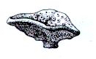
Raphidonema - (Triassic to Cretaceous) Examine the specimens of this calcareous sponge. Can you distinguish the type of canal system: ascon, sycon or leucon?

Astraeospongium - is a saucer-shaped sponge that is common in Middle Silurian rocks of the eastern States. The spicules have 6 rays in one plane (forming a star) and two button-like rays at right angles to them. Sketch a single spicule (10a) as well as the whole specimen (10b): use separate bar scales to show their relative sizes. Do you think the "saucer" was facing up or down during the life of the organism (10c), and why?

STROMAPOROIDS -- These are Middle Paleozoic sponges related to the modern sclerosponges. They secreted a heavy calcareous skeleton composed of concentric and encrusting layers and were the principal reef builders of their time. In many genera the structure is formed of thin laminae parallel to the growth surface and pillars that are perpendicular to that surface. The canal systems of the sponge are reflected in the skeleton as radiating channels on the surface called astrorhizae and similar canals within the skeleton. The living tissue occupied only the surface of the skeleton. Depending on the composition of their spicules, stromatoporoids are classified as either Demosponges (siliceous) or Calcisponges (calcitic or aragonitic).
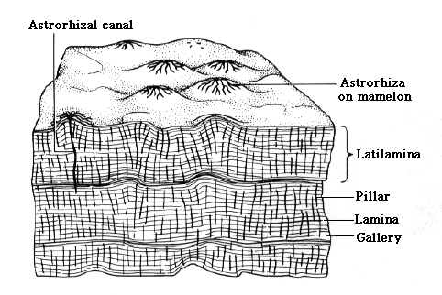
Labechia is an early, Ordovician representative of the group, which reached its peak diversity during the Silurian and Devonian periods.

Examine the specimens of Silurian and Devonian genera, and look for the faint microstructure defined defined by laminae and pillars. The overall external shape was probably strongly influenced by water currents and wave action.

How would you tell apart a stromatoporoid from a stromatolite (11)? (Go back to Question 1 for a reminder of what stromatolites look like...)

Class ARCHAEOCYATHA
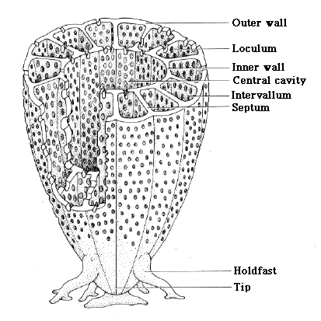
This group of fossils was long considered to be intermediate between the sponges and the cnidarians because they have the porous walls of the filter-feeding sponges and the radial partitions of the corals. They were hugely diverse but largely confined to Lower Cambrian rocks. At least one genus lived into Late Cambrian time.

Examine the specimens of archeocyathids and sketch one of the polished cross sections to show the inner cavity, the two walls, and the radial partitions (12a). How are they similar to or different from a fossil of a Paleozoic solitary horn coral (12b)?

Would you infer, from your observations and their timespan in the fossil record, that they are good or poor index fossils for the early Cambrian (12c)?

RECEPTACULITIDS

These are a group of enigmatic fossils (i.e. of uncertain affinity) that are probably not sponges but primitive plants. Receptaculites is a common fossil in Ordovician limestones in Quebec and Manitoba. It is saucer-shaped and may be as large as a dinner plate.
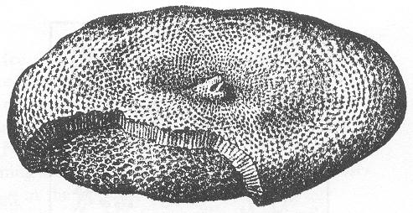
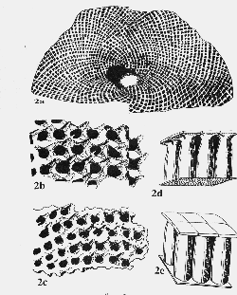
Examine specimens of this fossil. What features could have led scientists to confuse it with a poriferan (13)?

