EPSC 334 Invertebrate Paleontology

Laboratory Exercise #7: Bivalves

(class BIVALVIA, phylum MOLLUSCA)

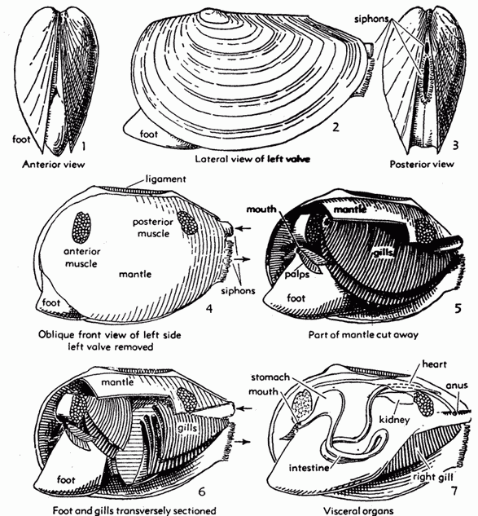
The bivalves are commonly referred to as clams. The class also goes by other names: Pelecypoda ("hatchet foot") or Lamellibranchia (a reference to the gills). Bivalves secrete two valves which are held on either side of the body and joined by a hinge mechanism at the top. The shells are secreted by two fleshy lobes of the body which line their inner surfaces and which constitute the “mantle”. When the shell is closed the two lobes of the mantle enclose a cavity in which the body of the animal is contained. On either side of the body, between it and the mantle, hang the gills by which the animals extract oxygen from the water.

Drawings from Moore et al. (1952)
A prominent part of the body is a large muscular foot capable of protruding through the opened valves in order to pull the animal along the sediment surface or to burrow in soft sediment. The organs of the bivalve are relatively complex and include a heart, digestive system, nerve system, excretion system, etc.

Early bivalves may have originally been mostly detritus (deposit) feeders, but they evolved into efficient filter feeders (i.e. feeding on particles suspended in water). They sample the water by means of two extensions from the back of the mantle that are called siphons. The water enters one siphon, circulates around the gills, past the mouth and exits by the other siplon carrying wastes from the anus with it. Bivalves living on the sediment surface have short siphons; those that burrow deeply have long ones.

The valves are open when the animal pushes out its foot to move. Some bivalves gape at the back even when their valves are closed, so that the siphons may hang out for feeding; others retract their siphons completely when the valves close. The muscles that close the valves are called adductors. There are two muscles in primitive bivalves and they cross directly between the valves. The valves are kept open by an elastic ligament which can be compressed or stretched by the closing muscles. When these muscles relax the ligament regains its form and opens the valves. Some ligaments are within the hingeline and act by compression; others are outside and act by tension.

The diversity of bivalve shell shapes can be related to ecomorphic groups, i.e. lifestyles to which the shell morphology is adapted. We cover the most common examples in this exercise.

Infaunal Bivalves: shallow versus deep burrowers.

Examine the interior of a valve of Mercenaria, a common modern clam. Sketch and label (1a) the following features: the teeth and sockets at the hinge line (do not confuse them with other ornamentation visible along the edge of the shell), the scars left by the muscles that close the valves, the pallial line along whicht he mantle is attached to the valve, the bend in the pallial line at the back of the valve marking the cavity into which the siphons could be withdrawn, and (if it wasn’t cleaned off) the dried up remains of the ligament which has been broken in separating the valves.
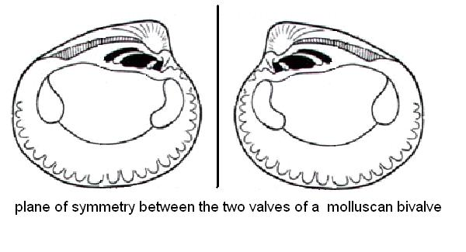
The “front” of a bivalve shell is indicated by the forward bending of the beaked region of the valve at which growth started. This beak is called the umbo. Hold the valve you sketched so that its umbo bends forward and points away from you: are you holding a left valve or a right one (1b)?

If you are confused, consider the example above: the beak of each valve bends towards the vertical line. The front side of the shell is towards this vertical line. Therefore these are (from left to right) a left- and a right-handed valve, respectively.

Pick up a pair of right and left valves. Do they show exactly the same features, already labelled on your sketch for 1a (1c)? How is this symmetry different from the one shown by the two valves of an articulate brachiopod (1d)?

Draw the interior of a valve from Mya arenaria (2a). Label the large spoon-shaped shelf, in the valve, which houses the internal ligament. This ligament is compressed when the valves are closed and it opens them by expanding when the adductors (muscles) relax. Label on your drawing the same features as those requested in question 1a for Mercenaria. Pick a pair of left- and right-handed valves and re-assemble them: do they shut tight or do they gape (2b)? This is typical of a deep burrower who uses long siphons.

Examine specimen N 10.1.T. What features of the specimen indicate that this is an internal mold (2c)? Compare the size of the bend in its pallial line of Mercenaria and Mya arenaria. Would it have been a shallower or deeper burrower than either one of these recent bivalves (2d)?

The classification of modern bivalves are based on their soft parts, which are less likely to show homeomorphy (i.e. convergent evolution) than the shell morphology. Paleontologists have had little choice but to concentrate their attention on the nature of the hinge teeth and shell shape and define form taxa.

Taxodonts vs. heterodonts: In most bivalves the hinge teeth are differentiated into a larger central group, elongated along axes at high angle to the hinge and, on either side of these, small linear ridges elongated parallel to the hinge (heterodont). In some bivalves, the teeth are all about the same size and are arranged in a line along the hinge like teeth on a saw (taxodont). These are two common types of dentitions among those recognized in bivalve taxonomy.

Which type of dentition (taxodont or heterodont) is shown by Mercenaria (3a), Arca (3b), Glycimeris (3c), Arenomya (3d) and Tellina (3e)?

Byssally Attached Bivalves: Bivalve larvae are attached to sediment grains by fine threads secreted by a gland on the rear of the foot. Some burrowing bivalves retain their byssal attachment into adulthood. Some byssally attached bivalves libed on the surface of the seafloor, attached to rocks or other shells. Many of them have a notch at the hinge line and many have a highly asymmetrical shell shape.

Draw the exterior of the Paleozoic bivalve Pterinea (N7.1.T) or the Mesozoic Avicula (7.2.T), labelling the byssal notch and showing the asymmetry of the shell shape (4a). The mussel Mytilus, a modern representative of this ecomorphic group, is abundant in the St. Lawrence estuary. Is each valve asymmetrical or equilateral (4b)?

The swimming bivalves arose from this group when they abandoned their byssal attachment.

Swimming Bivalves: Scallops push themselves through the water by clapping their valves together and jetting a stream of water in a direction controlled by the restriction of the jet by the mantle lobes. The muscle is reduced to a single very large one (the part you eat). Pecten and its many relatives are typical scallops. Note the bilateral symmetry of the shell and its ear-like projections on either side of the beak region. Can you locate any teeth or a ligament pit? Compare the symmetry of the shell shape, the shell thickness and its external ornamentation in Mytilus and Pecten and identify specific adaptations that might make the shell of Pecten better suited to swimming than Mytilus (5).

Cemented Bivalves: Oysters cement one of the valves to a solid object (a rock or even another shelly organism) and do not move about. Do the valves remain mirror images of each other (6a)? How do they differ in size and curvature (6b)? Which one of the two valves was cemented, and which one could be lifted by the animal (6c)?

Draw the inside of a larger valve of the common edible oyster Crassostrea virginica and label the large ligament pit and muscle scar(s) (6d). If you have tried shelling oysters, you know that having one less muscle (as in the swimming bivalves) seems not to have lessened the determination of the animal to keep its valves closed. Oysters are geologically important: they formed reef-like bodies at various times in the Mesozoic and Cenozoic when corals were in decline. The thorny reef oyster Spondylus is a common living genus which also cements itself to a firm substrate. Ostrea is a Cretaceous genus with strikingly developed ribbing.

Bivalves are rarely used in biostratigraphy because many of their shell shapes have reappeared repeatedly in different lineages with few distinguishing characteristics. However, during the late Mesozoic, some striking groups of oysters became particularly abundant.

Draw a specimen of either Exogyra or Gryphaea (7a), two genera of oysters that have a large lower valve and a smaller capping valve. In which genus is the beak region coiled in a plane at right angle to the plane between the valves (7b)? In which genus is the beak region coiled in the plane between the valves (7c)? Although Gryphaea was attached to the bottom in youth, it lay free in the muddy sediment when it was fully grown. Examine the slices cut through a specimen of Gryphaea. How can you tell apart the shell from the internal sediment that filled up the body cavity (7d)?

Another remarkable Mesozoic group were the rudists, who cemented one valve to a solid substrate and enlarged it to a conical form so that it resembled a horn coral. The other valve was reduced in advanced rudists to a small cap about a tenth the size of the lower valve. The resemblance of these clams to corals was not only in form but also in habitat: they grew into reef-like bodies. Some individual shells reached lengths of over a meter!

Examine the specimens of Requiena and Monopleura, rudists preserved in chalk. Of what Mesozoic period are they typical (8a)? Remember that some strophomenid brachiopods called richtofenids adopted a similar shape during the Permian (a late Paleozoic period)? If you could examine cross sections through these rudists, what features would you look for to confirm that were not corals (either tabulate, rugosan or scleractinian) nor brachiopods (8b)?

The freshwater clams. Most bivalves are marine but a small group migrated from the ocean into fresh water during the Silurian. How (9)? In these less saline waters they had the problem of keeping their shells from dissolving in water that is not saturated with CaCO₃. In the marine clams the outer covering of the shell is very thin: this is why the shell appears nearly white when the animal dies. In freshwater clams this outer covering, called the periostracum, is thick and black. Where it is worn away in the older parts of the shell, the revealed calcite tends to dissolve in the lake and river water.

Examine specimens of Unio and unionids, local lake clams, noting their inner pearly layers and outer periostracum. The inner “pearly” layer of these clams is composed of aragonite. The outer chalky layers are calcite. Most clams secreted both forms of calcium carbonate in different parts of their shells.

Boring Bivalves. Some bivalves are capable of boring into hard rocks or wood, apparently for protection. The wood borer, or shipworm, Teredo has lost almost all its shell and does immense damage to unprotected wood structures. What name is given to its burrow, a trace fossil (10)?

