Laboratory studies in Paleontology
Earth & Planetary Sciences EPSC334

Laboratory Exercise #5: TRILOBITES (phylum ARTHROPODA)

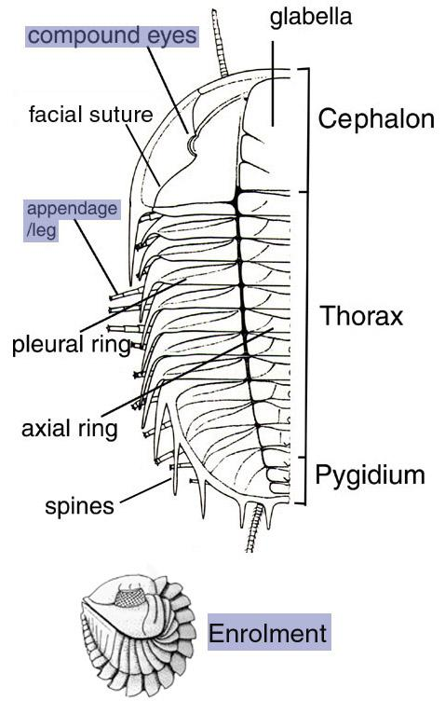
The arthropods are an invertebrate phylum characterized by segmentation, the specialization of various regions of the body, an exoskeleton which is jointed at the limbs, and blood cavities (among other features).

Although the exoskeleton makes an efficient support and armour, it inhibits the growth of the soft parts inside and must be periodically shed (molting) to allow this growth.

Each arthropod passes through a series of growth stages that give rise to a discarded exoskeleton which may form part of the fossil record. It is not surprising, therefore, that trilobites have a good fossil record. Yet fossils are rarely complete. The segments of the exoskeleton were held together by organic material which decomposed after death, usually allowing them to drift apart before burial.

The trilobites are usually considered to be a separate class within the phylum Arthropoda, characterized by many primitive features.

Their name refers to three longitudinal lobes, defined by two grooves that divide the body into an axial (central) and two pleural lobes (to the left and right of axial lobe). The cephalon (head) shows the most interesting features of the trilobite: a central raised part called the glabella, a line called suture along which the exoskeleton splits during molting, and the eyes on this suture.

Nearly all trilobite fossils are of the upper surface of the animal only. The undersurface must have been only lightly calcified and thin. The edges of the exoskeleton bend over to form a frame surrounding the undersurface. This frame, quite wide in such genera as Isotelus, is called the doublure. At the front of the undersurface of the cephalon a small plate called the hypostome is located just in front of the mouth.

Draw a complete specimen of one of the following genera: Ogygia, Ogygopsis, Olenoides (1). Mark as many of the identifiable features as you can: glabella, cephalon, pygidium, thorax, axial lobe, pleural lobes, facial suture, segments of the glabella (free and fixed cheeks), etc.

The cephalon of trilobites seemed to have been formed primitively by the fusion of several segments and the specialization of certain pair of appendages.

Examine plaster restorations of Triarthrus from the Middle Ordovician Utica shale. How many segments make up the cephalon (2a)? Does your answer make sense when you compare it to the number of glabellar furrows (2b)? What type and how many pairs of appendages are present on the cephalon (2c)?
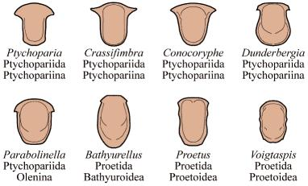
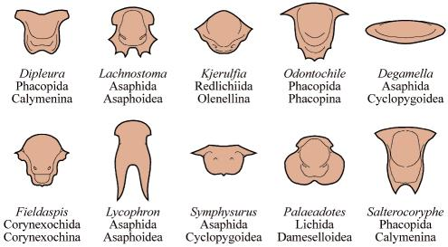

Look for its hypostome on the underside. Is this an example of a natant hypostome (left, above) or conterminant (more specialized) hypostome (right, above) ?

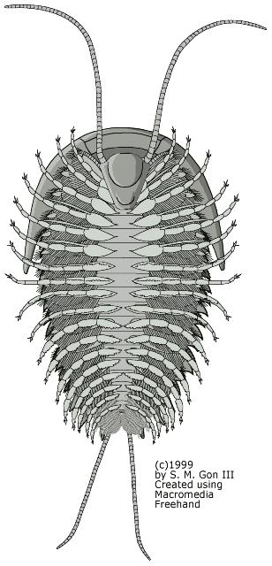
The appendages of trilobites are almost never preserved. When they are preserved they consist of delicate two-branched appendages that are similar on each segment but of different lengths.

Examine the specimens of Isotelus . Find a sketch the specimen displaying an undersurface with the hypostome and doublure (3a).

One specimen preserves appendages: on which part of the body are they present (3b)?

How can you tell the head from the tail on specimen O339.2 (3c)?

What type of observations would help determine whether the smaller specimen of Isotelus is an adult or a juvenile form of the larger specimens (3d)?

Preservation. Trilobite exoskeletons came apart easily, during or following molting or after the death of the animal. Sketch and identify the three most common types of fragments in specimen O224 of Glossopleura (4a)? Examine the larger limestone specimen, rich in Isotelus fragments. What is showing up as folded squiggly lines rather than distinct heads and tails (4b)? What is the evidence for calling this specimen a mold of the inner surface of a trilobite tail (4c)?

Examine enrolled specimens of the common Ordovician trilobite Flexicalymene and Homalonatus (Devonian). Compare them with the unrolled specimens of the Silurian Calymene. What part of their body were they protecting by enrollment (5a)? Why not protect their eyes instead (5b)?

One noteworthy aspect of the overall morphology of Cambrian trilobites is the size and shape comparison among their head and tail. Can you find examples of three trilobite genera that you could call macropygous (or isopygous) and three more that are micropygous (6)?

To see or not to see... The eyes of trilobites tell us something about their mode of life. In the earliest trilobites (the order Redlichiida, e.g. Olenellus) the nature of the eye is obscure and the eye area is usually preserved only as a hole in the cephalon.

In later trilobites the eyes are definitely compound like those of a fly and of two types: holochroal, with a single outer covering of the many lenses, and schizochroal, with opaque tissue separating the lenses.
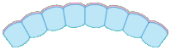
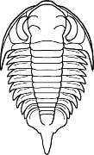
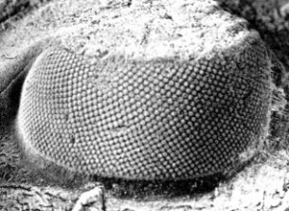

Left: Platyantyx, a proetid trilobite with holochroal eyes. Center: close-up of one of its eyes. Right: schematic cross-section showing close packed eye lenses.
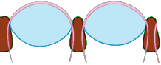
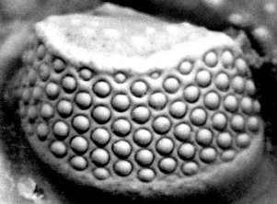
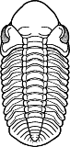

Left: Reedops, a phacopid trilobite with schizochroal eyes. Center: close-up of one of its eyes. Right: schematic cross section showing how the eyes lenses are set apart and embedded into a different tissue.

The holochroal type is more ancient. Unfortunately our specimens do not clearly show the lenses, but Aulacopleura and Albertella have this type of eye. Draw a closeup view of a cephalon to show the location and structure of the schizochroal eyes on Phacops (7).

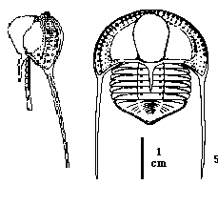
Some trilobites had raised eyes or were without eyes and therefore blind. Some of these are thought to have lived buried in bottom sediment. Draw the cephalon of the blind Ordovician trilobite Cryptolithus (8a), common in local rocks. What may have been the function of the pits within the brim surrounding the cephalon (8b)?

Examine and draw a specimen of Aqnostus (9a). Note that the cephalon and pygidium have separated in almost all specimens. Locate a separated pygidium and cephalon for your drawing. This genus is typical of the Middle and Late Cambrian order Agnostida. Would you describe it as isopygous, macropygous or micropygous (9b)? What type of eyes did this trilobite have (9c)? What was its mode of life: benthic or planktonic (9c)? How can this be inferred: from its morphology or from the distribution of its fossils (9d)?
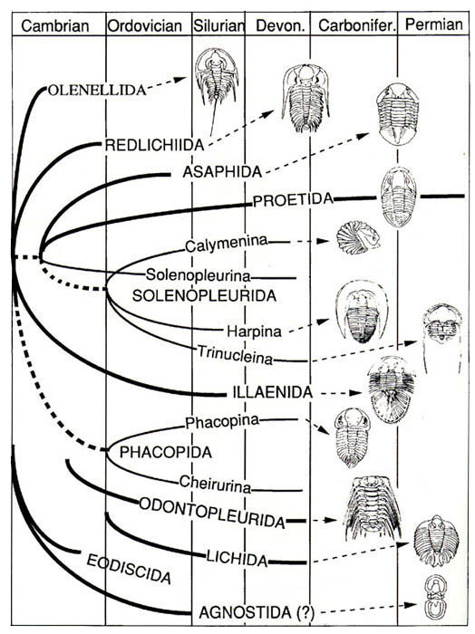
Sketch Eoharpes or Harpes (10a). How did its eyes differ from those of most other seeing trilobites according to LEVIN (10b)?

Examine the trace fossils attributed to trilobites. How are they thought to have been produced (11a)? How far back in time have they been observed (11b)?

BURGESS SHALE FAUNA

Examine the suite of fossils from the Burgess Shale. Is there evidence of more than one mode of preservation among the specimens (12)? Justify your answer with some observations.

What order of trilobite is represented among the specimens? (ORDERS are CAPITALIZED on the chart to the left. No written answer is required).

