QUESTION 1a.

Examine then draw the specimen of the modern brachiopod, Lingula, which has been dissected and embedded in plastic (1a). Label all the elements you can recognize (e.g. lophophore, pedicle, muscles, internal organs (undifferentiated), and shell).
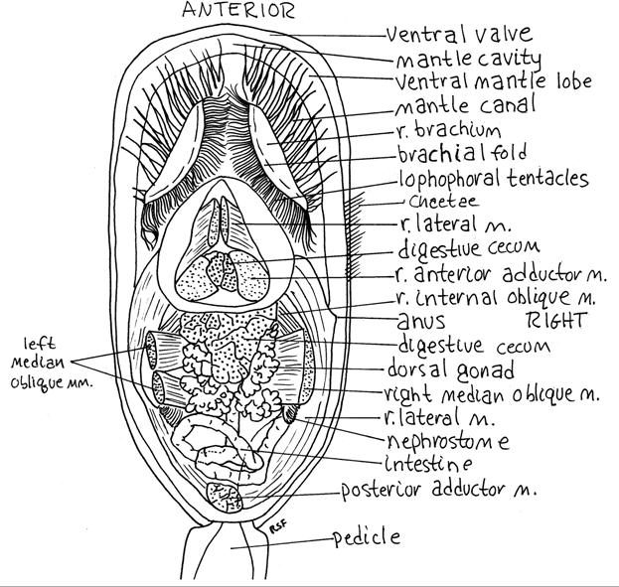
Below, left: the animal in living position.
Below, right: a detailed sketch of a dissected Lingula ("m." stands for muscles) to help you find features on the actual specimen.
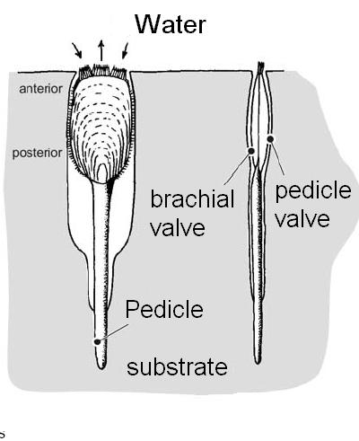
Question 1b.
Examine the specimens of Lingula from local Paleozoic rocks. Are the specimens (of Ordovician and/or Silurian age) preserved in sandstone, siltstone, shale or limestone (1b)?

A reminder:

- sandstone: a gritty sedimentary rock made of compacted grains of quartz (a very hard mineral), typical of high-energy beach environments.

- siltstone: a sedimentary rock, finer-grained than a sandstone. May contain various proportions of ground up quartz and feldspar grains, and clay minerals. If calcareous, a weak reaction to dilute HCl should occur.

- shale: a very fine-grained sedimentary rock, usually composed dominantly of clay minerals, typically softer than a sandstone, and commonly fissile. May be calcareous (weak reaction to dilute HCl).

- limestone: any rock composed dominantly of CaCO₃ (calcite or aragonite). Should react vigorously to dilute HCl.
QUESTIONS 1c, 1d.

Paleozoic specimens of Lingula are often better preserved than more recent (Cenozoic) fossils. In what type of sediment does Lingula live today (1c)?

Could this partly explain its unusual longevity as a genus and the deterioration in its preservation (1d)?
Question 1e.

A non-renewable resource…

Examine the coquina of another inarticulate brachiopod brachiopod, Obolus. Like Lingula's, its shell is chitinophosphatic. Why is this deposit mined (1e)?
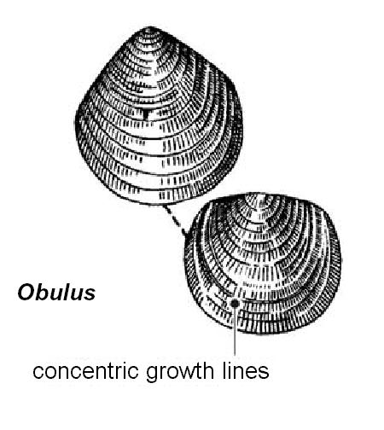
Question 2:

CALCIATA - CRANIIFORMEA
(inarticulate calcareous brachiopods)

Examine specimens of Trimerella, a trimerellid common in Silurian reef limestones. What is the mode of preservation of these specimens: replacement, permineralization, mold or cast (if one of last two cases, specify if internal or external) (2a)?

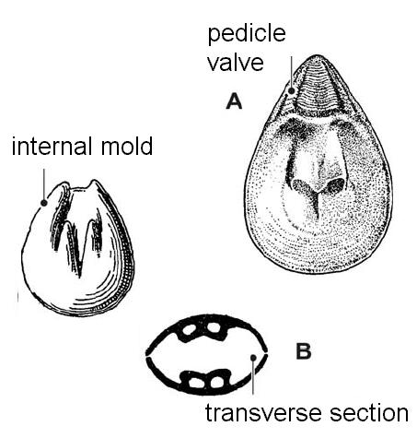
This extinct genus is known nearly only from molds. What does this mode of preservation suggest about the original shell mineralogy (2b)?

Sketch the pattern of deep grooves on the fossils (2c). They represent a mineralized ridge and platform for the attachment of muscles inside the shells.
Question 3.

CALCIATA – ARTICULATA
The articulate brachiopods

The main orders of articulate brachiopods are relatively easy to recognize from the overall shape of the shell. Look at the specimens set aside for this question, and match each genus to one of the orders described below. Consult the chart for diagrams displaying a typical shell morphology in each order.

(3a) Orthids are articulate brachiopods with unequally biconvex strophic shells. (Note: strophic refers to a hinge line that extends along the full width of the shell.)The shells display distinct radial ridges (costae). The hingeline varies in length from genus to genus.

(3b) Strophomenids secrete thin shells with fine radial ornaments (costellae) and long, straight hingelines.

(3c) Spiriferids typically have long hinge lines, and their shape is commonly compared to the winged insignia of airline pilots. The radial ridges (costae) are usually more developed than in the strophomenids.

(3d) Terebratulids have shells that are typically smooth, thick and elongate. Most of the living brachiopods belong to this group but the first representatives appeared in mid-Paleozoic rocks.

(3e) Rhynchonellids are characterized by a short hingeline and triangular shape. Paleozoic genera often show very coarse ribbing (called costae).

(3f) Pentamerids are mid-Paleozoic brachiopods that secreted mostly large, smooth, thick shells. In specimens preserved as internal molds, prominent grooves mark the position of platforms to which muscles were attached. The muscles, shorter, could exert a stronger pull on the heavy valves.

Question 4:

SHELL SHAPES of brachiopods

Specific terms are used to described the shell shapes displayed by brachiopods. Use the figure below to identify the shell shapes displayed by four genera on display (4a, b, c, d). Note that the letters “b” and “p” refer to the brachial and pedicle valves, respectively.

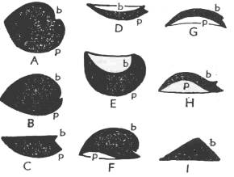

A, B: biconvex
C: plano-convex
D, E: concavo-convex
F: convexo-concave
G: convexo-concave
H: resupinate (brachial = convex to concave)
I: convexo-plane

Question 7:

Diagnostic features of orders of articulate brachiopods

strophic: hinge line extends full width of the shell
astrophic: next to the hinge, the shell edges are curved
Order-Suborder | Convexity | Pedicle opening | Hinge | H:L | Other
Orthida | valves are unequally biconvex | triangular | strophic | < 1 | diverging costae
Strophomenidina | plano-concavo-  convex | absent | strophic | 1 | thin-shelled
Chonetidina | plano-concavo-convex | absent | strophic | 1 | spines on hinge
Productidina | plano-concavo-convex | absent | strophic | 1 | spines on pedicle valve
Pentamerida | biconvex | absent | astrophic | -- | medial septum
Rhynchonellida | biconvex | absent | astrophic | -- | strongly plicate
Atrypidina | biconvex | small | astrophic | -- | often costate
Spiriferidina | biconvex | triangular | strophic | 1 | wing-shaped
Athyrididina | biconvex | circular, small | astrophic | -- | often smooth
Terebratulida | biconvex | circular | astrophic | -- | smooth
Question 5a, b:
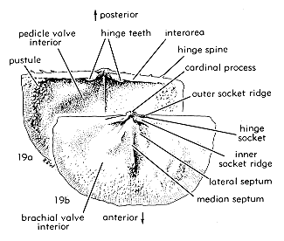
Interior of brachiopod valves

Any brachiopod valve may be either concave, flat, or convex. Therefore you cannot assume that the concave side of a shell is the interior of a valve.
How, then, can you tell that you are looking at the interior of a single valve (5a)? List the features that are present (and contrast them with those absent from the interior but present on the exterior of a valve).

Identify and draw the interior of a single valve among the few set aside for this purpose (e.g., Rafinesquina, or Strophomena) (5b). Label as many features as you can see: cardinal process, muscle scars, pedicle opening, etc.

Question 5b, c:
Compare the diagrams to the valve you chose to draw for 5b, and determine if you are dealing with a brachial or a pedicle valve.

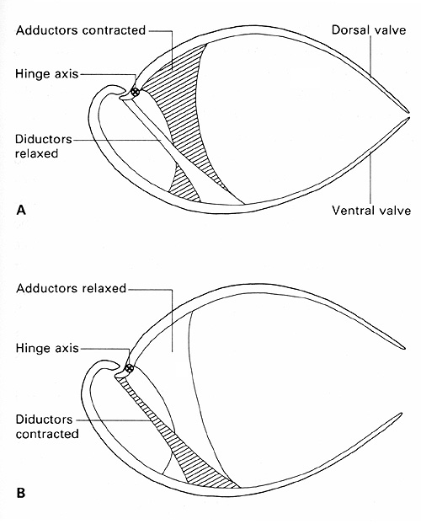
If the muscle scars were well preserved on the valve you chose to draw for 5b, should they have been left by the adductor muscles or the diductor muscles (5c)?

Question 6:

Use it or lose it…

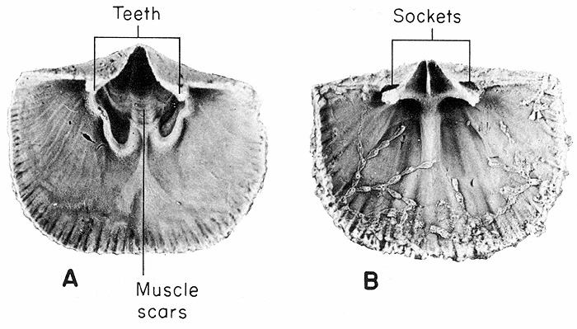

The teeth are borne on the pedicle valve (A, on the left), and matching sockets are found on the brachial valve (B, on the right). Note that the pedicle valve is the larger valve. In this example, the pedicle valve (A, on the left) shows a triangular foramen (opening) where the pedicle was protruding.

In some brachiopods the pedicle was reduced and the shell rested free on the ocean floor. Make a sketch of the hinge area of the shell so that you may show the foramen (a technical term for the opening through which the pedicle normally protrudes) of Spinocyrtia and Strophomena (6a). In which of these two genera has the pedicle been lost (6b)?
Question 7a.

Chonetids and productids

The spines of these types of brachiopods are often broken, leaving only small bumps on the valves. These spines are thought to have acted as "snowshoes", to help the animal stabilize its position in soft muddy sediments.
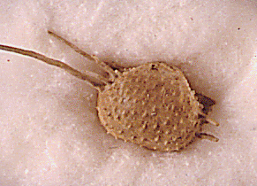

Productids and chonetids are suborders.

To which order (orthid, strophomenid, spiriferid, atrypid, rhynchonellid, terebratulid) do they belong (7a)? If you cannot figure it out, look up the chart posted on WebCT (or the lecture notes for this week).
Question 7b, c.

Examine and draw one of the following genera of spiny brachiopods: Marginifera or Linoproductus (7b).

What was the purpose of the little bumps visible on the surface of the shells (7c)?

Note that the front of the productids is also commonly broken. This often happens during collecting because the front of the productid shell was extended into a flat, thin margin called a "trail" that allowed the buried organism to have access to water above the surface of the sediment.

QUESTION 8.

THE BRACHIDIUM

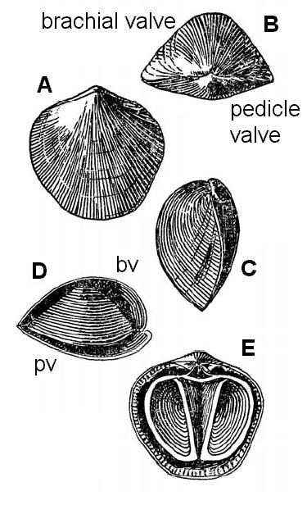
Examine Mucrospirifer or Athyris, spiriferids that were cut and polished or broken to show the spiral-shaped calcite ribbon inside, also called a brachidium. Sketch one example.

What is the function of this ribbon (8a)?

Which valve (brachial or pedicle) carries the brachidium (8b)?

Examine also the other specimens with different types of brachidia.
QUESTION 9.

MODES OF FOSSILIZATION

Examine the three specimens set aside for question 9a, 9b, 9c.

Describe, in each case, the evidence that lets you identify their modes of preservation (permineralization, interior/exterior mold or cast, replacement)?

Note that you can only recognize a cast without ambiguity if you find the matching mold when you collect it, or if you prepare a thin section to check that the actual shell microstructure is present.

Permineralization occurs in brachiopod shells but its effects are not visible to the naked eye because the shells have only microscopic pores (or no pores at all).

QUESTION 10.

Examine examples of rhynchonellid brachiopods.

How do you expect the flow rate of water entering the shell to change as the shape of the commissure (i.e. the area of the shell where the brachial and pedicle valve gape to let water in) is modified from a straight to a zigzag shape (10a)?

The diagram below shows how particles of different sizes can get in along the commissure.

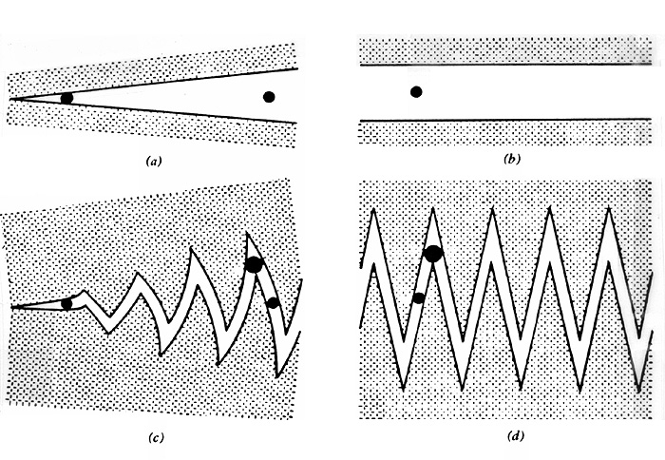
What might be the advantage to a filter-feeding rhynchonellid of developing a zigzag shape at its commissure (10b)?
QUESTION 11.

Compare the specimens of Hemythyris to those of Waldheimia and Terebratula. Is the pedicle functional in all three genera (11a)?

How does the ornamentation of the shell identify one of these genera as a rhynchonellid and the other two as terebratulids (11b)?
QUESTION 12.

Examine the huge slab of limestone in the lobby of the museum; it is crawling with brachiopods!

Can you find more than one type of brachiopod? Sketch their overall shell shapes (12a).

To which order (orthid, strophomenid, pentamerid, rhynchonellid, spiriferid or terebratulid) would you assign them, given their overall shell shape and ornamentation (12b)?

Label on your sketch the characters that you used for identification (12c).
QUESTION 13.

A HAPPY PAIR?

Examine the Rhynchotrema joined to a rugose coral.

Did one of the two animals have to die before the other one could attach itself to it, or could this have been a mutually beneficial arrangement (13)?

Justify your answer by explaining where the soft parts of each animal would have been present. Don’t forget to consider the tentacles equipped with stinging cells that the rugose coral (a cnidarian) is thought to have possessed.

