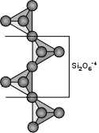
Inosilicate

pyroxenoid (single-chain silicate)

Rhodonite, MnSiO₃

Diagnostic features: usually recognized by pink colour, moderate hardness (5.5-6: barely scratched by a knife) and rather poor cleavage (no better than in the pyroxenes, at 87 and 93°).
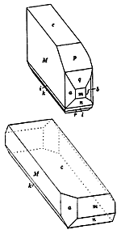
Habit: often in massive aggregates, rarely shows crystal forms.

Colour: pink, due to manganese (Mn).

Occurrence: rhodonite occurs in manganese deposits and manganese-rich iron formations, as a result of metamorphic and hydrothermal alteration. It is often associated with other manganese minerals such as manganite and pyrolusite.
Inosilicate

pyroxenoid (single-chain silicate)

Wollastonite CaSiO₃

Diagnostic features: moderate hardness, rather poor cleavage and its association with Ca-rich minerals.

This mineral is a common product of metamorphism of limestone (a rock mostly made of CaCO3 minerals) by silicate magma. It is therefore often associated with calcite. Can be quite difficult to tell apart from tremolite when it occurs in small radiating clusters of crystals. Its cleavage is much poorer than that of tremolite.

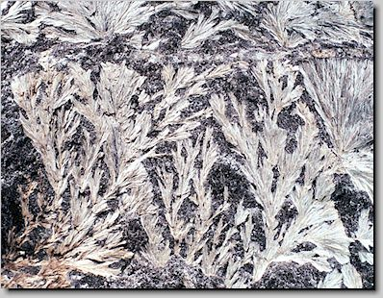
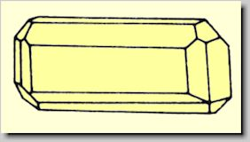
Mixed Neso-Sorosilicate

Vesuvianite Ca₁₀(Mg, Fe)₂ Al₄ (SiO₄)₅ (Si₂O₇)₂ (OH)₄

Diagnostic features: tetragonal prismatic habit, vitreous luster, moderate hardness.

Habit: stubby prismatic crystals, habit similar to zircon crystals (but not as hard).

Colour: usually deep green to black. However, Thetford Mines is famous for its pink vesuvianite.
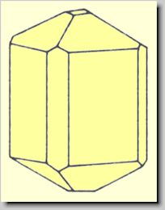
Cyclosilicate

Cordierite

Diagnostic features: Metamorphic mineral usually found as coarse crystals in the finer-grained matrix of schists.
Harder than the knife on fresh surfaces (7-7.5) and displaying poor cleavage.

Habit: well-formed crystals are rare.

Colour: variable but shades of bluish grey are common. Translucent crystals are remarkable for the change in colour ("dichroism") seen when they are looked at parallel to the c axis and then perpendicular to the same axis.
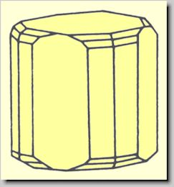
Oxide

Pyrolusite MnO₂

Diagnostic features: low hardness (H = 1-2, often soils the fingers). Colour of the mineral is same as its iron-black streak.

Habit: rarely in well-developed crystals. Usually in radiating fibers or columns. Also granular massive.

Colour: iron-black. Streak: same.

May be associated with other manganese-rich minerals (e.g. rhodonite, rhodochrosite).
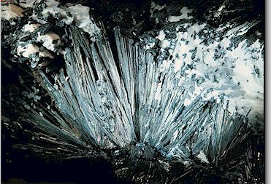
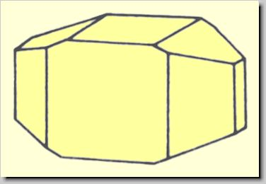
Hydroxide

Manganite, MnO(OH)

Diagnostic features: black, metallic luster, distinctly prismatic and striated crystals.

Hardness: 4 (harder than pyrolusite).

Colour: steel-gray to iron-black. Streak: dark brown.

Habit: prismatic crystals are usually striated along their long axis. Often columnar to coarse fibrous, and twinned as both contact and penetration twins.
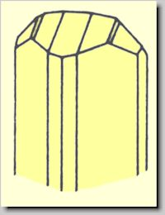
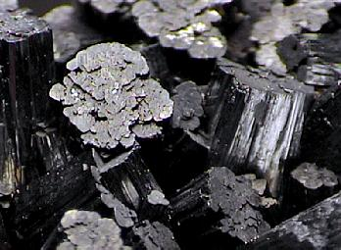
Hydroxide

Brucite, Mg(OH)₂

Diagnostic features: foliated nature, light colour and pearly luster on cleavage face. Distinguished from talc by its greater hardness (H = 2½), and lack of greasy feel, and from mica by being inelastic.

Habit: commonly foliated or massive. Crystals are usually tabular on {0001}.

Colour: white, gray or light green.

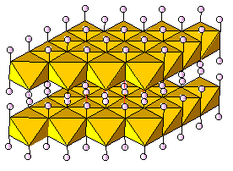
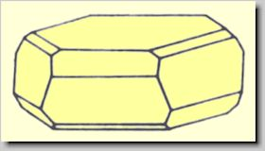
Brucite is usually the result of hydrothermal alteration of a Mg-rich rock, and it is usually found associated with serpentine, dolomite, magnesite and chromite. The structure consists of layers of Mg(O,OH)₆ octahedra that are only weakly held by hydrogen bonding (H--O).
oxide

ilmenite FeTiO₃

Diagnostic features: distinguished from hematite by a darker streak, black to brownish-red, and from magnetite by its lack of strong magnetism.

Habit: similar to hematite but rhombohedral crystals are rare and their truncation by basal planes makes them look tabular. Often in thin plates, or massive and compact. Some black sands are rich in grains of ilmenite.

Colour: iron-black. Streak: black to brownish-red.

Ilmenite may be weakly magnetic. It is a common accessory mineral in igneous rocks and vein deposits.
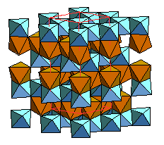
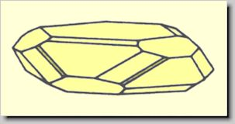
oxide

rutile TiO₂

Diagnostic features: adamantine luster, tetragonal prismatic crystals and the contrast between its deep (often slightly reddish) colour and pale brown streak.

Habit: prismatic crystals with dipyramid terminations, and vertically striated prism faces. Twinning is common.

Colour: red, reddish-brown to black. Streak: pale brown.

Hardness: 6-6.5

Occurrence: common in siliceous igneous and metamorphic rocks (granites, pegmatites, gneisses, mica schists, metamorphosed limestones). Sometimes found as needle-like inclusions in quartz and micas.

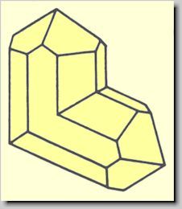
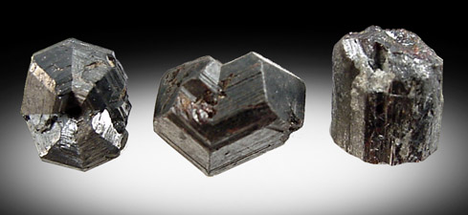

oxide

cuprite Cu₂O

Diagnostic features: reddish colour and brownish-red streak, low hardness (3.5-4) and common association with other copper minerals.

Habit: massive or as isometric crystals (cube, octahedron or dodecahedron, often combined). Chalcotrichite is a variety of cuprite that is also known as "plush copper", because of its unusual fur-like habit.

Colour: Red. Streak: brownish-red.

Cuprite is an important copper ore. It is found in the oxidized portion of veins of metallic copper, associated with limonite and secondary copper minerals such as native copper, malachite, azurite, and chrysocolla.
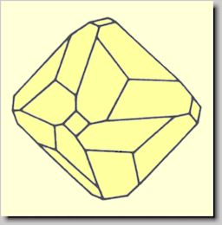
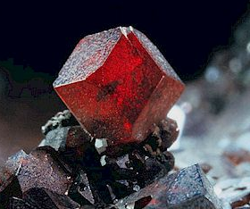
oxide

chromite FeCr₂O₄

Diagnostic features: its "pitchy" luster (i.e. a rather dull, submetallic luster which makes it look like a lump of asphalt or tar) distinguishes it from ilmenite, and its lack of magnetism distinguishes it from magnetite.

Habit: most commonly massive, granular to compact. Rarely in octahedral crystals.

Hardness: 5.5

Colour: iron-black to brownish black. Streak: dark brown.

Chromite is a common constituent of dark, olivine-rich igneous rocks (e.g. peridotite, a rock derived from the upper mantle) and of the serpentines (antigorite/chrysotile-rich rock) derived by the hydrothermal alteration of olivine-rich rocks.
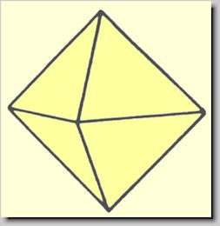
oxide

corundum Al₂O₃

Diagnostic features: vitreous luster, often with rhombohedral parting. The parting and/or growth features often produce triangular patterns on the basal parallelohedron {0001}. Its high hardness (H = 9) is somewhat misleading because the surface of corundum easily alters to a much softer mica, and can only be observed on a freshly broken surface.

Habit: crystals are six-sided, in prismatic columns or tabular.

Colour: colourless when pure, but quite variable when impurities are present. Sapphire is coloured blue by electron transfers between trace amounts of Fe²⁺ and Ti⁴⁺. Ruby is coloured red by trace amounts of Cr³⁺.

This mineral has exactly the same structure as hematite but the strength of the Al-O bond gives it a much higher hardness. The six-sidedness of the crystals reflects the hexagonal close-packing of the oxygen ions.
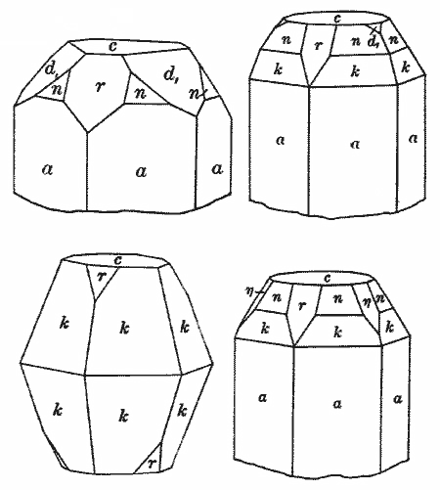
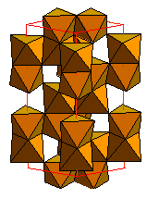
oxide

hematite Fe₂O₃

Diagnostic features: dark reddish streak. The streak is darker in pure specimens (but magnetite may also be present). The streak is much lighter (reddish brown) when the mineral is dispersed among white-streak minerals.

Habit: crystals are rare but they have a three-sided symmetry (middle photograph, below) which reflects the hexagonal close packing of the oxygen ions. Also seen in reniform aggregates (below, right). Hematite often coats other iron-bearing minerals as a weathering product.

Colour: varies from metallic black in larger crystals, to ocher (brownish red) in fine-grained aggregates. Luster also varies wildly, from metallic on large crystals to dull on fine-grained aggregates.

Hardness: 5.5 - 6.5, but hard to evaluate if small crystals are dispersed in the rock.

This mineral has exactly the same structure as corundum, but consists of Fe³⁺ O₆ octahedra. It is an important iron ore, but not the richest one. Small quantities of magnetite are often present with hematite, giving some hematite-rich specimens a slight magnetism. Check both streak and magnetism to recognize hematite-magnetite mixtures!
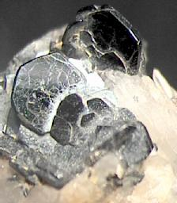
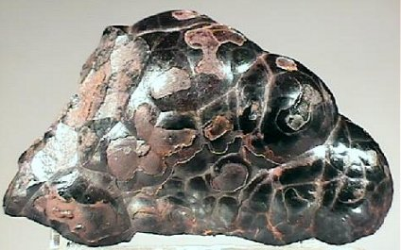
hydroxides

limonite FeO(OH) • H₂O and goethite FeO(OH)

These two minerals often occur together and most of their properties are similar. Limonite is a field term for any rock composed of brown iron oxide that does not have the distinct habit of goethite. X-ray diffraction must be used to tell them apart in the laboratory: limonite is amorphous while goethite is crystalline.

Habit: goethite may form prismatic crystals with vertical striations, often packed in dense radiating aggregates. When the mineral looks "earthy", with no evidence of crystallinity, the name "limonite" is used.

Colour: both limonite and goethite are yellowish brown to dark brown, with a yellowish brown streak.

Hardness: 5-5.5

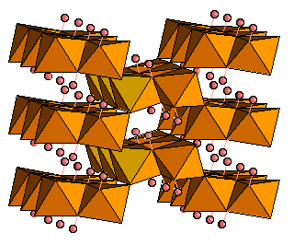
Like hematite, these iron-bearing minerals are common alteration products of the weathering of other Fe-bearing minerals. They forms the iron-rich surface rock called “gossan” over ore bodies containing pyrite, FeS₂. Limonite/goethite are not rich ore minerals, but can be surface indicators of an underground Fe-rich orebody.
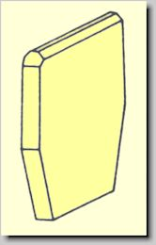
oxide

magnetite Fe₃O₄ ( = Fe²⁺Fe³⁺₂O₄)

Diagnostic features: strong magnetism, black colour and black streak.

Habit: crystals are rare but are usually octahedral when visible. Magnetite usually occurs in massive aggregates.

Colour: black, with a bright metallic luster on fresh surfaces.

Hardness: 6.

Less abundant than hematite but richer in Fe (and easier to separate economically from the gangue minerals surrounding it, because of its magnetism), magnetite is an important ore mineral when it occurs in massive aggregates. It is also rather common as small scattered crystals in many magmatic, metamorphic rocks and sedimentary rocks. This is the mineral that usually preserves the "remanent magnetism" (fossil magnetic field) of rocks used to infer the past movements of continents throughout their geological history.
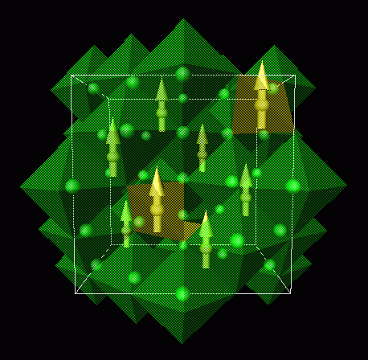
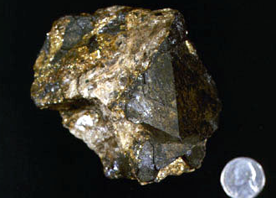
hydroxides

bauxite: a rock rich in minerals such as Al(OH)₃ and AlO(OH)

The minerals making up the rock are mostly gibbsite Al(OH)₃, boehmite and diaspore, the latter being two polymorphs of AlO(OH).

Diagnostic features: low density (G: 2-2.55), earthy or pisolitic habit (shown in picture below).

Habit: often earthy or pisolitic. Crystals are not visible because they are submicroscopic.

Colour: dull to earthy white, yellow, gray or red (the colour is due to scattered impurities such as tiny crystals of hematite or goethite).

Hardness: 1-3.

Bauxite is the only ore from which aluminum is currently economically extracted and refined. The minerals are the result of intense weathering and leaching, in tropical climates, of feldspar-rich rocks (the silica and cations are leached away as the structure of the feldspar breaks down to clay minerals, such as kaolinite, and finally to these simpler hydroxides).
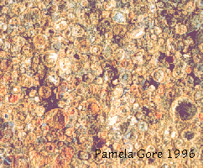
Nesosilicate

Titanite: CaTiO(SiO₄)

Diagnostic features: the wedge-shaped crystals and high luster are characteristic.

Habit: the flattened monoclinic crystals are wedge-shaped. Cleavage and parting may be visible but neither is striking.

Hardness: 5-5.5 (can be scratched, barely, by a knife).

Colour: usually dark, brown or black. However, green, yellow or gray crystals are known and the mineral is occasionally transparent to translucent.

