EPSC 210 Introductory Mineralogy - Mid-term examination October 11, 2007

Answer any five questions (out of 6). Only the best answers will count towards your total grade. Each question has equal weight. This exam is worth 20% of your final grade but, if you do better on the final exam, this one won’t count.

Question 1. Indicate if each statement is true or false, and briefly justify your answer. Note: these justifications are longer than what I required. Many students got full marks for giving just enough information to disprove any part of these statement.

- Alpha-quartz (class 32) forms when beta-quartz (class 622) cools and instantaneously undergoes a reconstructive transformation. False. A reconstructive transformation involves breaking bonds and forming new ones, so it is not instantaneous (as is a displacive transformation, which is how beta- becomes alpha-quartz).
- A tetragonal prism is a variable form because the unit cells of different tetragonal minerals have different unit lengths along their a and c axes. False, a tetragonal prism is invariable because its interfacial angles must be 90 degrees. This is a consequence of axes a and b being of the same unit length and perpendicular in that system.
- In the Herman-Mauguin class 6/m, the form {0001} is a parallelohedron, but in the class $\overline{3}$, the same Miller indices describe a rhombohedron. False, producing a rhombohedron requires that the faces intercept at least the a or b axis as well as the c axis. These indices will produce a parallelohedron in both classes.
- The various types of cleavage (prismatic, pinacoidal, octahedral) reflect mistakes during crystal growth and they are controlled by symmetry that the crystal structure does not actually have. False. This definition corresponds to twinning. Cleavage is due to a lower density of -- or weaker -- bonds across certain atomic layers in a crystal structure, and these planes of weakness are repeated by the symmetry of the crystal structure.

Question 2. Follow the instructions and build the following stereographic projection…
- sketch a stereogram showing the position of the symmetry elements of class 422. Answer shown on the left.
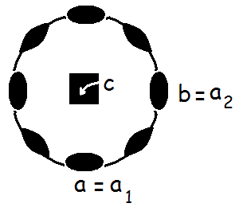
- indicate on the stereogram the orientation of axes a, b and c (rename them, if it is appropriate for the crystallographic system of that class) Answer shown on the left.
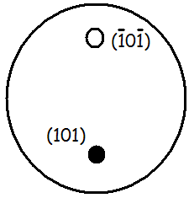
- show with dots (open or full, as appropriate) the position of the faces (1 0 1) and ($\overline{1}$0$\overline{1}$) Shown on the right.
- are these faces of the same kind (i.e. are they related by symmetry in that class)? Yes (related by the 2-fold rotation parallel to the b axis).

- plot on the stereogram other faces of {1 0 1} generated in class 422 and give their Miller indices. Shown below: eight faces make up this form in class 422.

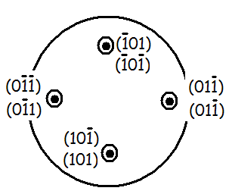
- is {1 0 1} a closed form or an open form?
A closed form if you found all eight faces. If you found only 4 of them, the resulting form appears open.

- would you describe the resulting habit as prismatic? Justify your answer. A stereogram doesn’t really display habit because it doesn’t give the relative size of faces. If this was the only form present, however, the habit would be dipyramidal. Some of you plotted a prism and if you recognized it as such, you got credit for an answer consistent with your stereogram.

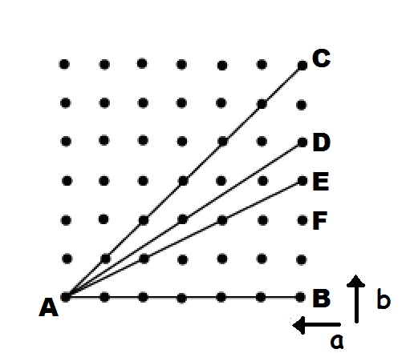
Question 3. Consider the sketch (on the left) of a slice through a lattice. The orientation of two axes a, b, is indicated.

a) which interaxial angle (alpha, beta or gamma) can be measured directly on the sketch? The angle between axes a and b is called gamma (γ).

b) from the unit lengths and interaxial angle shown in the sketch, to which crystallographic system could this lattice belong? (Without information about the c axis, there may be more than one valid answer…) Since the spacing of nodes along axes a and b is the same, the system must be tetragonal or isometric. It could be orthorhombic if the lattice was pseudo-symmetric. It can’t be hexagonal (gamma should be 120°).

c) what are the intercepts of planes AB, and AD on the axes shown, and to what Miller indices do they convert to? The plane AB intercepts the b axis and is parallel to the a axis. The inverse of these intercepts (1/∞ and 1/1) are the Miller indices (0 1). There was no penalty for arbitrarily adding a third Miller index of “0” but that value is, in fact, unknown. The plane AD goes 6 unit lengths along the a axis for every 4 unit lengths along the b axis. These intercepts invert to (1/6, ¼) and must be multiplied by 12 to clear the fractions, giving (2 3).

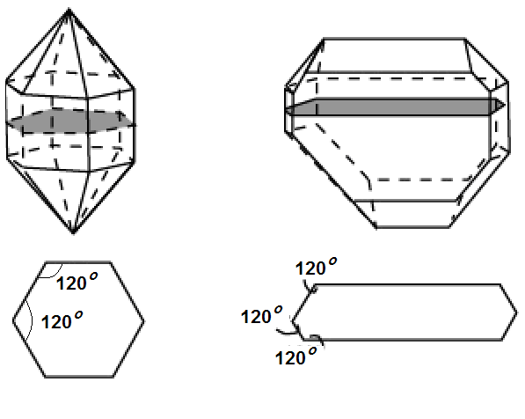
Question 4. These two crystals have the same composition: SiO₂. The drawings below show interfacial angles measured for a cross section through the middle of each crystal. You have the tools to measure any physical properties (hardness, specific gravity, type of or absence of cleavage).

a) These two crystals may look different because they are different polymorphs of SiO₂ !... What property (Moh’s hardness, specific gravity or the type or absence of cleavage) would be most convincing if you wish to test this hypothesis? Polymorphs share the same composition but the symmetry of the atomic pattern is different and distances between atomic layers may be different (remember graphite and carbon?) ... Differences in specific gravity are most common, but changes in hardness and cleavage are also possible.

b) If both crystals are found to be alpha-quartz, maybe one is a pseudomorph after a different mineral. Would this give the two alpha-quartz crystals different physical properties (e.g. hardness, specific gravity, type of or absence of cleavage)? Since the two crystals have the same atomic pattern and composition, they share the same properties. If one is a pseudomorph after a different mineral, it only gives it a different outer shape.

c) Perhaps these two crystals are simply examples of Steno’s law. In such is the case, do they share a similar habit, or do they share similar forms? This law states that the size of faces of the same kind may differ among crystals but their interfacial angles are constant for a given mineral species. Crystals illustrating this law would share the same forms but faces of different sizes give them different habits.

Question 5. The following sketch is a crystal of the amphibole hornblende (class 2/m), showing its main forms, {0 1 1}, {0 1 0} and {1 1 0} and the trace of its cleavage.

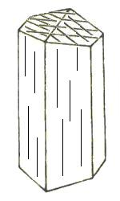
a) show on the figure how you would orient the axes a, b and c relative to the drawing. Hint: the c axis is vertical (parallel to the page) and β = 105.5° Answer given below. I also indexed the faces mentioned in the question, so you see how you could have used them to infer the location of the axes.
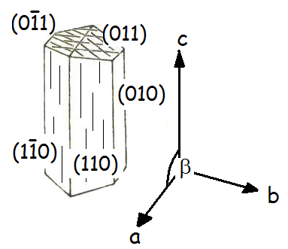
.
b) why is the {110} cleavage called prismatic rather than pinacoidal?
The cleavage (oblique lines on the top faces) is parallel to the (110) face and three others of the same kind. These {110} faces are parallel to the same axis, c, defining an orthorhombic prism. A pinacoidal cleavage would be parallel to the faces of a parallelohedron.
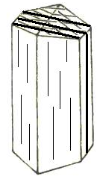
c) this crystal cannot have an enantiomorph. Why? It already has a center of inversion and a mirror plane. A mirror image of it will look identical (congruent). Enantiomorphs lack these symmetry elements and can exist in left- and right-handed versions.

d) polysynthetic {100} lamellar twins are sometimes seen in hornblende. In which orientation would the lamellae (i.e. slices of crystals related by the twin law) appear on the drawing? These indices denote planes parallel to the b and c axes. The sketch to the left shows how these planes would cut across the crystal faces.

Question 6. Answers in lecture notes. Cyclic twins were often confused with polysynthetic twins (parallel composition planes). The notation for [0001], a vector parallel to the c axis was often confused for the face (0001), a plane which intercepts the c axis.

