Name/ID:________________________________
EPSC 210 Introductory Mineralogy
Mid-term examination Thursday - October 12, 2006
Answer any four questions out of 5. Only the best answers will count towards your total grade. Each question has equal weight. This exam is worth 20% of your final grade but, if you do better on the final exam, this one won’t count.
Question #1. Is each of the following statement TRUE or FALSE? In each case, provide a brief explanation for your answer.
a) a cubic habit refers to a crystal made up of six faces that do not necessarily belong to the same form, and whose interfacial angles may have any value. Answer: False, the angles between the six faces should be close to 90 degrees, but they don’t have to be exactly of that value since habit refers to the overall aspect of a crystal and not to its exact crystallographic forms. The faces do not have to be of the same kind to give a cubic habit (but they would if they made up the form “cube”).
b) The Miller indices [0001] refer to a closed form in the hexagonal class 6. Answer: false, indices in square brackets refer to a direction (here the direction parallel to the c axis). The indices {0001} would refer to a form, and it would not be closed.
c) Trapezohedra can exist as enantiomorphs (i.e. occur in right-handed and left-handed versions) because mirror planes are part of their symmetry. Answer: False. Trapezohedra do not have mirror planes as part of their symmetry.
d) Triclinic microcline (1) may twin by a 3-fold rotation twin law because its structure is so close to that of monoclinic orthoclase (3/m), a clear case of pseudosymmetry. Answer: False. 3/m is not a monoclinic class.
e) In a triclinic crystal, the angle between (100) and (001) is rarely 90 degrees. Answer: True. There are no symmetry operations (rotations or reflections) requiring the axes to be mutually perpendicular in that system.
Question #2. Follow the instructions and answer the questions.
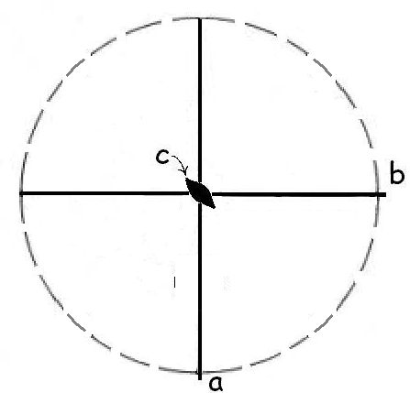
a) Draw a stereogram showing the symmetry elements of the crystal class m m 2. Answer: shown on the left. Note that the rim of the projection is left as a dashed line.
b) Show on the stereogram the position of the axes a, b and c. Answer: shown on the left. Orthorhombic axes are perpendicular.
c) Show by dots (full or open) the relative position of the faces (1 1 1) and (3 1 0) on the stereogram (assume that the unit lengths of a and b have very close values). Answer: stereogram below, left. Dots should be full because the faces intercept only the positive ends of axes.
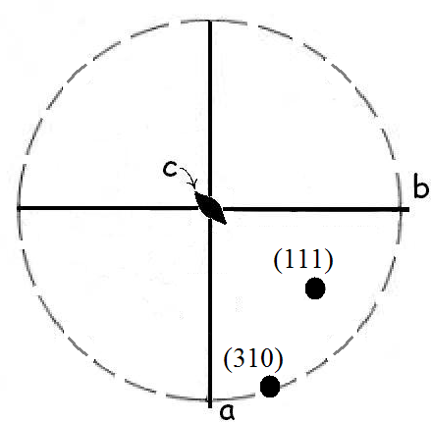
d) Are the faces (1 1 1) and (3 1 0) related by any of the symmetry elements present in this crystal class? Answer: no.
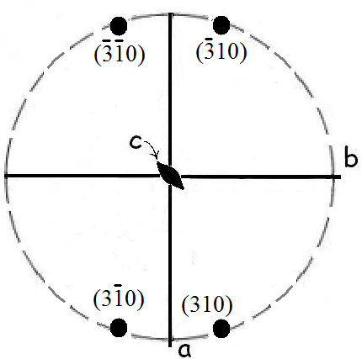
e) Use the symmetry of this crystal class to find the position of other faces belonging to the form {3 1 0}. Show them as full or open dots on the stereogram, and give the Miller indices of each face. Answer: stereogram to the right. All dots are full because they are vertical faces (neither on top nor on bottom half).
f) Is the form {3 1 0} an example of an open form? Briefly justify your answer. Answer: yes. The four faces are parallel to the same axis (c axis) and do not meet at the top nor at the bottom of the form (it is a prism).

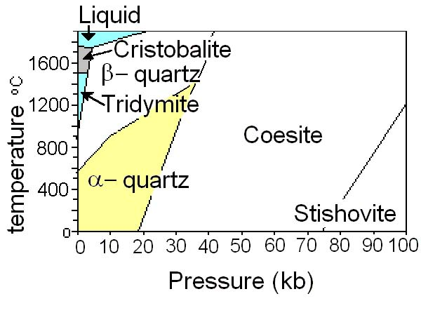
Question #3. We discussed alpha-quartz and beta-quartz in class, but there are 22 known crystalline structures for SiO2! The diagram below shows some of their stability fields. The polymorphs have the following symmetry and specific gravity: cristobalite (422, G = 2.32), tridymite (222, G = 2.26), beta-quartz (622, G = 2.53), alpha-quartz (32, G = 2.65), coesite (2/m, G = 3.01), and stishovite (4/m 2/m 2/m, G = 4.35).

a) According to this diagram, which of the following polymorph of SiO2 might transform to beta-quartz during cooling: cristobalite, alpha-quartz, or coesite? Answer: “cooling” means going down in temperature. On the diagram, one could draw a vertical line going down from either the cristobalite or the tridymite field and reach beta-quartz.
b) The special property of quartz as an oscillator used in watches depends on the absence of a center of inversion. What other polymorphs of quartz also lack centrosymmetry? Answer: according to their crystal classes, cristobalite, tridymite and alpha-quartz all lack a center of inversion because they do not include the combination 2/m.
c) Is there a general relationship between pressure, temperature and the specific gravity of these polymorphs? Justify your answer by comparing specific minerals that would convert to each other (either by heating or by compression). Answer: pairs of minerals related by heating (e.g. beta-quartz heated to cristobalite) go down in specific gravity. Pairs related by compression (e.g. beta-quartz compressed to coesite) increase in specific gravity.
d) If alpha-quartz form by the reconstructive transformation of coesite, what type of forms do you expect such alpha-quartz crystals to display? Answer: New bonds will form at the atomic scale but the mineral could keep the shape of its precursor (pseudomorphism) in which case the alpha-quartz crystals will look monoclinic (2/m: parallelohedra and rhombic prisms). Only if new faces can grow will the alpha-quartz crystals show a hexagonal prism or a rhombohedron.
e) Can you think of another process (than reconstructive transformation) that could also produce alpha-quartz pseudomorphs of coesite crystals? Describe it briefly. Answer: the coesite crystal, formed at great depths, could be dissolved near the Earth’s surface and the space left in the rock filled by water carrying dissolved silica so that the low-temperature polymorph could crystallize in it.

Question #4. (Note: There may be more than one possible answer to each of the following questions, and the same drawing may be used for more than one answer.)
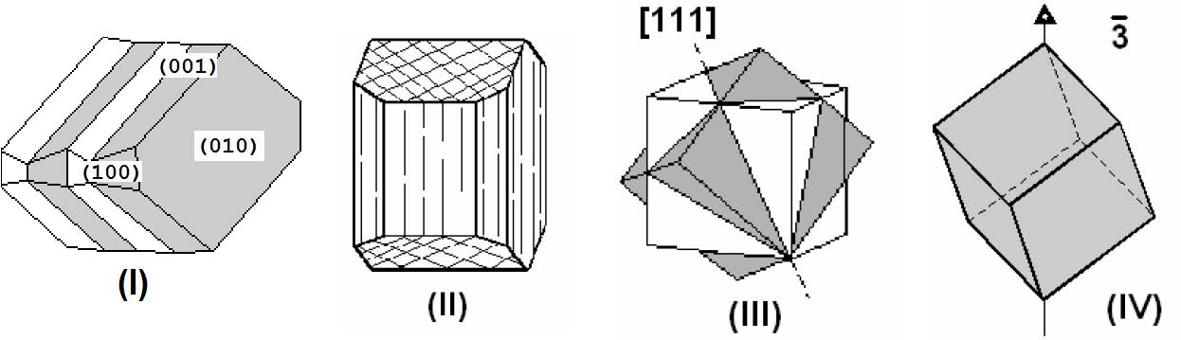
Select one drawing among those above (numbered I to IV) that displays the feature mentioned below …
a) … at least one invariable form (mark with an “i” one face of any invariable form you recognize). Answer: parallelohedra are visible in (I), (II) and a cube in (III).
b)… a vector used as a twin law. Answer: [111] in drawing (III).
c) … a polysynthetic twin. Answer: crystal (I)
d) … a centrosymmetric crystal (briefly explain what you look for in the drawings) . Answer: possibly all these drawings, if each face has an identical one, inverted and parallel on the opposite side of the crystal.
e) … a prismatic cleavage (show on the drawing the axis parallel to the cleavage
planes). Answer: on crystal (II),the vertical and criss-crossing lines follow the vertical faces of the rhombic prism. They are parallel to a vertical axis.
Question #5. Define any three ( and only 3) of the following six terms. Use a sketch, if appropriate, to explain your answer.
Stenos’ law rhombohedron displacive transformation
(0001) monoclinic system lattice

Examples of appropriate answers:

- “Steno’s law” refers to the law of constancy of angles, i.e. the faces of the same kind will show the same interfacial angles on different crystals of the same mineral.
- (0001) are the Miller indices of a face with intercepts of infinity on the a₁, a₂, and a₃ axes of a hexagonal lattice, and with an intercept on the positive end of the c axis.
- rhombohedron: a six-faced, closed form that resembles a cube but with a single 3-fold rotoinversion axis.
- monoclinic system: one of 6 main crystallographic system, where the axes a, b and c do not have to have identical unit lengths, and where one interaxial angle (beta) does not have to be 90 degrees.
- displacive transformation: transformation among polymorphs that does not require the breaking of bonds or formation of new ones
- lattice: idealized representation of a crystal structure consisting of an array of nodes (points) with identical environments.

