186-233A Earth & Life History

Mid-term examination - Monday October 15, 2001

Answers are posted as Acrobat PDF file on WebCT, and are also accessible via the Earth & Planetary Sciences web site:
go to: www.eps.mcgill.ca
On the upper line of the screen, click on "department"
Last item on the menu (left-hand side) is "Course Web Pages". Click on it.
Select 186-233 from the list of courses and click on the link to the syllabus.
There is a link to the mid-term and answers near the top of the syllabus.

This mid-term examination accounts for 25% of your total course grade.

Answer any four (4) of the five (5) questions. Each question is worth 25% of the total exam. If you get a false start on any one question, move on to the next one. I will only grade the 4 best answers.

- Match each of the following statements, a) to h), to an appropriate rock type among those listed below (some rock types do not correspond to any of the statements):
- tillites, Grypania-bearing shales, graywackes, turbidites, red beds, banded iron formations, nearshore sandstones, volcanic ash bed, stromatolitic limestone, uraninite-bearing conglomerates.

- This rock type appeared during the Archean and the early Proterozoic eons. Its presence suggests that the Earth's early atmosphere contained hardly any oxygen while parts of the oceans may have been oxygenated.
- This rock type is limited to the Archean eon and could not have formed if rivers carrying such pebbles had been in contact with an oxygenated atmosphere.
- This rock type becomes abundant during the early to middle part of the Proterozoic eon and it contains iron in a form which suggests that the level of atmospheric oxygen had risen significantly since Archean time.
- This rock typically forms in calm offshore waters but this particular example contains a eukaryotic fossil of Precambrian age.
- This rock type occurs sporadically throughout Earth's history and formed when glaciers carried rocks from continents and dropped them into deep waters.
- This rock type contains trace fossils, and is more likely to be found in a Precambrian thrust-and-fold belt than in an Archean greenstone belt.
- This rock type is likely to include minerals containing radioactive elements and their daugther elements which will yield a reliable absolute age.
- This rock type is common in the stratigraphic record after Archean time, but it rarely contains well-preserved fossils.

- Supercontinents existed at various times throughout Earth's history.
- List three kinds of information used by earth scientists to reconstruct the position and shape or size of Rodinia (Precambrian) or Gondwanaland (early to Middle Paleozoic).
- Name two factors which seem to have increased the likelihood of triggering an ice age while these large continental masses were present.
- What kind of isotopic data (i.e. radiogenic or stable isotopes, and of what element, and from what geological material) can be used to confirm other physical evidence that an ice age took place?

- a) Some of the characteristics below belong to greenstone belts found in Abitibi, others to thrust-and-fold belts like the Wopmay. Sort them out under these two categories:
i) graywackes and shales
ii) marine sedimentary rocks deposited in shallow water environments
iii) belts of relatively small width
iv) altered volcanic rocks that were originally ultramafic in composition
v) wide igneous belt bordered by a metamorphic zone
vi) association with gold and metallic ore deposits that are mined today
vii) found along the margin of small felsic cratons
viii) broad sheets of sedimentary rocks thrust over large cratons

b) The heat flow during the Archean eon was likely higher than in Precambrian time because short-lived radiogenic elements were still decaying, and the once molten Earth was losing heat at a faster rate in its early history than later on. Did this favour the development of greenstone belts or thrust-and-fold belts, and why?

- Some striking differences exist between the Ediacaran fauna and the early Paleozoic fauna (all the Cambrian fauna). Sort the following characteristics according to these groups.
i) absence of mineralized hard parts
ii) preservation in sandstone
iii) body plans including limbs and mouth
iv) evidence of complex burrowing behaviour
v) preservation in limestone and shale
vi) scarcity of stromatolitic limestone
vii) diverse ecological roles (filter feeders, grazers, predators, plankton)
viii) mineralized hard parts that covered most of the body

b) Do your categories suggest that life progressed from simpler to more complex forms (from Proterozoic to Cambrian time), or does it indicate that evolution occasionally led to innovations that left no descendants? Briefly justify your answer in a few sentences.
- Examine the following diagram. It represents two sections, widely separated geographically. They include two unfossiliferous datable rock formations (III and VI) and others containing fossils. Straight lines within shale beds (I and IV) represent the orientation of layering within these formations.

- Where, in this diagram, is there evidence of an unconformity?

- Does formation VI provide a youngest or oldest possible age for the other formations?

- What is the most likely explanation for the presence, in formations II and IV, of different types of fossils: a difference in their absolute age, or a difference of environment in which each formation accumulated?

- Formation V has been correlated between the two sections. Does this rely on the presence of formation VI, the presence of nautiloid fossils, or the similar rock type (limestone) found at both sections? Justify your answer briefly.
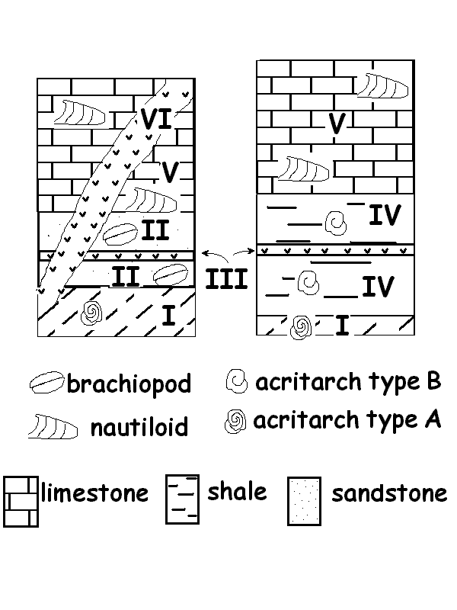

Answers to Mid-term examination given on October 17, 2001.

1. Match each statement to an appropriate rock type:

- Banded iron formations (BIFs
- Uraninite-bearing conglomerates
- red beds
- Grypania-bearing shales (Note: Stromatolitic limestones contain layered trace fossils and cellular filaments from cyanobacterial mats, which are prokaryotic organisms.)
- Tillite
- Stromatolitic limestones (note: nearshore sandstones was also accepted)
- Volcanic ash beds (Only partial marks were given for uraninite-bearing conglomerates… Although uraninite contains uranium and, therefore, can be dated, the uraninite is eroded from sources that could be of several different ages. Dating uraninite pebbles gives the age of their igneous source(s), rather than the age of their deposition in conglomerates on river beds.)
- Nearshore sandstones

2. Supercontinents existed at various times throughout Earth's history.
- Full marks given for a total of any three of the following lines of evidence used by earth scientists to reconstruct their position, shape and size:
- the paleomagnetism preserved in certain igneous and sedimentary rocks provides information about the latitudes at which they acquired their magnetism in the past
- chains of mountain building zones (orogenies) of similar age found on continents that are now separated may indicate that they were once sutured into a single larger continent.
- similarities in the types of fossils on continents that are now separated
- similarities in the types and sequences of sedimentary rocks found near the edge of ancient cratons
- radiometric dating of igneous rocks (volcanic lavas or ash beds) found below and above sedimentary rock layers, can prove the similar age of sedimentary rocks that show similar sequences on separate continents (and might have been derived from a mountain belt formed when these continents were first sutured into a supercontinent)

- Any two of the three following factors:
- reverse greenhouse effect caused by a drop in the level of atmospheric CO₂. [This could happen because of an increased productivity of organic matter, combined with its fast burial rate in sediments (preventing the decomposition of dead organic matter to release CO₂ back to the atmosphere).]
- movement of large landmasses towards higher latitudes, closer to either the North or South pole… this tends to promote the accumulation of snow on land which reflects back solar radiation and further cools the climate;
- cycles in the intensity of solar radiation reaching the Earth.

- [Note: this is material to be presented on October 2nd) Dating evidence (such as tillites or striations on continental rocks) is not a confirmation that an ice age took place. To properly answer the question, one had to identify a type of isotopic signal which is directly influenced by processes taking place during an ice age. The best answer was the proportions of stable isotopes of oxygen (O¹⁸ /O¹⁶) which can be analyzed from fossil marine CaCO₃ shells (such as brachiopods). The reason? Marine shells record the proportion of these stable isotopes of oxygen left in the seawater during the growth of ice caps. Ice caps tend to draw O¹⁶ in greater proportions than its average concentration in seawater because this lighter isotope evaporates faster from tropical waters than the heavier O¹⁸ and doesn't condense (and rain down) as fast as O¹⁸. Marks were also given for answering “stable isotopes of carbon, i.e. C ¹³/C ¹² from marine CaCO₃ shells”. These isotopes record a possible side effect of an ice age. This effect is the increased weathering of organic matter (which has lower C ¹³/C ¹² proportions than total average carbon) that was buried in sediments, on continental shelves, before the glaciation, but becomes exposed to erosion, weathering and decomposition because the sea level drops while ice caps grow.

3.a) Characteristics of greenstone belts in Abitibi:
- i) graywackes and shales
- iii) belts of relatively small width
- iv) altered volcanic rocks that were originally ultramafic in composition
- vi) association with gold and other metallic ore deposits that are mined today
- vii) found along the margin of small felsic cratons

Characteristics of thrust-and-fold belts (Proterozoic Wopmay orogen, Paleozoic Appalachians):
- ii) marine sedimentary rocks deposited in shallow-water environments
- v) wide igneous belt bordered by a metamorphic zone
- vii) broad sheets of sedimentary rocks thrust over large cratons

b) The high heat flow during the Archean eon kept the crust relatively thin and mostly mafic (i.e. much like the mantle in its chemical composition), and convection during the mantle was more intense than later on. As a result, cratons were kept small because they rifted (i.e. broke up) more often. The subduction of oceanic crust led to collisions of small cratons between which were trapped narrow belts of ultramafic volcanic rocks and sedimentary rocks. Sedimentary rocks like graywackes and shales accumulated because material eroded from continental rocks was not subjected to the intense wave action (because of frequent rifiting, the edges of continents were kept “young” and steep and did not have time to erode into broad shallow shelves). In contrast, thrust-and fold belts contain thick sheets of sandstones and limestones belts which formed on broad shallow-water continental platforms but were thrust and folded when they were pushed on the edge of larger cratons as they collided (instead of getting subducted into the mantle like old, dense oceanic crust).

4. a) Ediacaran (also called Precambrian or Vendian fauna) fauna shows:
- absence of mineralized hard parts
ii) preservation in sandstone

The earliest Paleozoic fauna (small shelly fossils, Tommotian and Burgess Shale faunas) show:
iii) body plans including limbs and mouths (not found in Ediacaran fossils)
iv) evidence of complex burrowing behaviour (Ediacaran-age sediments show far less burrows and they tend to be simple resting traces rather than complex feeding traces)
v) preservation in limestone and shales
vi) scarcity of stromatolitic limestone (presumably because grazing animals were now feeding heavily on cyanobacterial mats)
vii) diverse ecological roles (predators, herbivores, deposit feeders, filter feeders)
viii) mineralized hard parts that covered most of the body

b) You were expected to justify your answer by using what you had just sorted out in two categories… You could illustrate progress from simpler to more complex forms of life by pointing out the decline of fossils left by prokaryotes (vi) , the increasingly complex behaviour of animals larger than unicellular eukaryotes suggested by (iv) and (vii), the evolution of complex body plans including mouth and limbs (iii) and mineralized hard parts (viii). The only element suggesting that the Ediacaran fauna produced innovations that left no descendants is the strange preservation of Ediacaran fossils in sandstones rather than in limestone or shale. This was interpreted by some as a sign that Ediacaran animals were covered by a tough membrane unlike the soft-bodied organisms preserved in the middle Cambrian Burgess Shale or the marine animals living today.

5. a) an unconformity is evidence of erosion or non-deposition between two sedimentary formations. Evidence of an unconformity therefore appears at the contact between formations. An unconformity could be detected within a sedimentary rock formation if the formation clearly contained an incomplete succession of fossils from its bottom to its top. The best answer was "between I and II in the first section and/or "between I and IV" in the second section. The most convincing evidence was the change in the orientation of layering (not horizontal in formation I, but horizontal in formation IV) which suggested that formation I was deposited, then tilted (by movement along a fault during extension or compression of the crust) before sedimentation started again.

b) Formation VI crosscuts formations I to VI because it is an igneous intrusion (you are also told that it is datable and unfossiliferous, and the symbol does not correspond to any of the sedimentary rock types given in the legend). An intrusion can only penetrate through formations that are already laid down, so its age is younger than any of the formations that are crosscut.

c) Formations II and IV both contain a datable formation, labelled III at both sites because its age is identical at both locations. Therefore, formations II and IV could be about the same age (at least right below and above the marker bed III). They consist of different rock types, however, which indicate different environments of deposition. Sandstones generally accumulates in nearshore marine environments with energetic wave action, while shale accumulates in calmer (often deeper) water. Their different fossils probably also have different environmental requirements during life.

- A correlation is an interpretation of some kind of equivalence established between rocks that are geographically separated. Lithologic correlation could be done here on the basis of similar rock type (limestone); this reflects an interpretation that these two limestones, now found at widely separated locations, accumulated under similar environmental conditions. Stratigraphic or temporal correlation, done on the basis of similar index fossils, is an interpretation that both limestones were deposited during the same interval of time. Nautiloids, being swimming predators rather than bottom-dwelling filter-feeders, are likely to be good index fossils, i.e. they consist of genera and species that appeared for relatively short intervals in the fossil record.

