Captions for Appalachians (including ophiolite localities)
Below: Quartz veins in alpine clefts.
Caption: Alpine clefts opened by mineral collectors seeking quartz crystals as depicted in the inset. Route 55 road cut. Photo: J-Y. Lamoureux
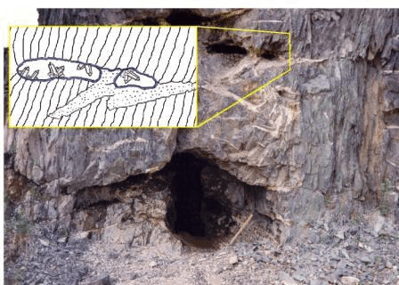
ALPINE CLEFTS

Quartz veins frequently cut the highly folded metasediments of the Appalachian Orogen, commonly perpendicular to their schistosity. They are the result of tectonic forces acting on the rocks as they were folded. The veins sometimes contain lenticular-shaped cavities called alpine clefts. Crystals of quartz and other minerals have been found in such clefts exposed in road cuts along Route 55 near Windsor.

Below: Orford nickel mine, footwall.
Caption: Footwall of the Orford nickel mine in 1992.
The filled-in south shaft is below the figure. Photo: A. Tarassoff
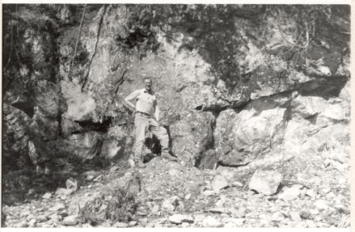
THE ORFORD NICKEL MINE

The Orford mine was the first nickel mine in Canada but operated for only a short time from 1877 to 1879. It is a classic locality for specimens of chromian grossular, diopside and millerite. The mine remains a popular mineral collecting site to this day.

Below: Jeffrey mine, open pit.
Caption: The Jeffrey open pit is 1800 metres across, and 380 metres deep. La mine à ciel ouvert de Jeffrey atteignant un diamètre de 1800 mètres et un profondeur de 380 mètres. Photo: P. Tarassoff
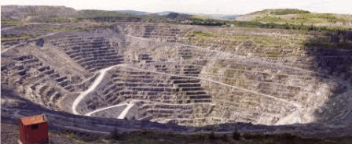
MINERALS FROM THE JEFFREY MINE

The Jeffrey mine in the town of Asbestos is world-famous for its exceptional specimens of grossular garnet, vesuvianite and other minerals. Mining of the asbestos deposit, the second largest in the world, began in 1879. At its peak production, the mine produced about 13 per cent of the world’s chrysotile asbestos. The Jeffrey mine is the source of the asbestos fibre used to protect the engines of the space shuttles Discovery and Atlantis during liftoff.

The asbestos occurs in a highly serpentinized ultramafic rock called harzburgite which represents ancient oceanic crust. Crystals of grossular and other minerals are found in open fissures in metasomatized dioritic and granitic rocks in contact with the harzburgite.

The Jeffrey mine is the type locality for two minerals, spertiniite and jeffreyite.

