EPSC233 Earth & Life History

Mid-term examination - Answers and comments

This mid-term examination accounts for 25% of your total course grade.

Answer any four (4) of the five (5) questions. Each question is worth 25% of the total exam. If you get a false start on any one question, move on to the next one. Only the 4 best answers will be graded.

Question #1. The composition of ancient rocks and the fossils found in some of them can be interpreted as evidence that atmospheric oxygen rose progressively throughout the early Earth history. A) Rank the statements below (numbered i to v) chronologically, to describe the sequence of events that took place in respond to rising levels of atmospheric oxygen. B) Indicate which statements describe signs of prokaryotic life, and which ones describe signs of eukaryotic life.

- Impressions of limbless, mouthless life forms are preserved in some sandstones.
- Beds of ancient chert contain cell-like fossils that are never larger than 10 micrometers.
- Sandstones deposited in ancient river deltas were stained red when grains of pyrite (iron sulfide) eroded from the continent rusted to form iron oxide coatings on quartz grains.
- Microscopic fossils, 30 to 50 micrometers across, called acritarchs, became very diverse in sedimentary rocks.
- Rivers once carried pebbles of pyrite and uraninite without any sign that these minerals rusted away before becoming part of conglomerates.
- Grypania is a centimeter-size carbon-rich coiled ribbon found in some banded iron formations

Answer: Part A) The most accurate answer was: v, ii, vi, iii, iv, i. You were not asked for a justification, but here it is. There were two lines of evidence presented in these statements. One was the succession of rock types that reflect increasing amounts of atmospheric oxygen: uraninite-pyrite conglomerates, banded iron formations, sandstones… The other was the succession of increasingly complex fossil evidence of life which required increasing amounts of oxygen (dissolved in seawater): smallest single cells in Archean chert, acritarchs are larger cells that also more diverse, the larger multicellular Grypania, and finally the Ediacaran fossils which are preserved in sandstones (rocks that start as a coarse grainy material in which microbial cells cannot be fossilized). Part B): statement ii) about the smallest fossils of single cells, never larger than 10 micrometers, describes what are inferred to be the simpler prokaryotes. Larger cells and larger fossils of statements i), iv) and vi) refer to eukaryotic forms of life, which required greater concentrations of free oxygen.

Question #2. Reefs have existed at various times throughout Earth's history but they were built by very different types of organisms.

- What life forms built reefs during Precambrian time (synonym for Archean + Proterozoic eons), the Cambrian period and the Ordovician period?
Answer: Cyanobacteria (also accepted: prokaryotic cells, blue-green algae) built Precambrian stromatolites; archeocyathids (also accepted: an extinct type of sponge) or calcareous algae (in case of the escarpment next to the Burgess Shale) built Cambrian reefs; primitive corals, stromatoporoids and bryozoans built Ordovician reefs. I was looking for at least one type of organism for each time interval, and a sign of awareness that different types of organisms had built reefs.

- Why are fossilized reefs such an important source of information about the development of ancient marine life?

Answer: in the past (and today), reefs were consistently populated by a diverse community of organisms. Although reefs declined in importance during certain periods, new organisms evolved repeatedly to take up the role of reef builders. In addition to the reef builders, other animals used the reef as a substrate to anchor themselves, hide or seek preys. Unlike soft sea-floor sediment, reefs are a solid structure from the start. During compaction, the reef framework remains largely intact. Many organisms attached to it are therefore fossilized in the positions they occupied during their life. Others accumulate as debris within and around the reef. (Other elements for which I gave some credit were the distribution of reefs as a paleoclimatic indicator, and the possibility of getting stable isotopic ratios of C and O from the calcium carbonate material of the fossilized organisms which can be interpreted in terms of marine productivity and paleoclimate).

- Reefal limestones preserve evidence of an Ordovician radiation of marine invertebrates. What does the term “radiation” mean?

Answer: radiation generally refers to the diversification of a given taxon (a group of organisms) within a relatively short interval of time. During a radiation, many groups (families, genera or species) related to a common ancestor appear nearly simultaneously in the fossil record.
Question #3. This diagram illustrates some of the geological structures mapped around the thrust-and-fold belt of the Wopmay orogen (northwestern Canada).

Error: Reference source not found
- Why can the granite intrusion be used to determine the youngest possible age of the Wopmay orogen?

Answer: The granite contains minerals that trapped radioactive elements from the magma during its crystallization. Its absolute age can therefore be determined by radiometric dating. This age must be the youngest possible age of the orogen (i.e. the episode of mountain building) because the granite cuts across (intrudes) the rocks that were pushed on the edge of the Archean continental crust during the plate collision that provoked the orogen.

- Is this type of tectonic activity most likely to have taken place at the edge of a Proterozoic continent, or near the center of the continent?

Answer: This type of activity is typical of a plate collision, which occurs at the edge of tectonic plates. Subduction of oceanic crust results in its partial melting (this is how the granitic magma is produced) and the compression is responsible for thrusting sedimentary rocks on the Archean craton.

- Different types of sedimentary rocks are found in the “thrust-and-fold belt” (turbidites, shale and limestone), the “passive margin sequence” (sandstone and limestone) and the “molasse” (marine shallow-water and volcanic debris)? Explain why these differences occur, and what were the likely source(s) of the sediments before and during the orogen.

Answer: The rocks present in the thrust-and-fold belt were first deposited as sediment on the edge of the continent before the orogen. This is where they became compacted into rocks. They were later pushed (thrusted) onto the edge of the continent during the orogen. They represent sediments originally deposited in moderately deep water (limestone) and deeper water (shale and turbidites). The “passive margin sequence” was also deposited on the edge of the continent, in shallower water (limestone) and closer to the seashore (sandstone). The “molasse” formed during and after the orogen, by erosion of the volcanic arc formed during the orogen and the shallow-water sediments raised above sealevel by the mountain-building activity.

This schematic stratigraphic column depicts a sequence of sedimentary rocks. A genus of bivalve has been found only in the sandstone layers (stippled pattern): one such layer is at the top and the other at the bottom of the column… Each of the three layers of shale (dashed pattern) found between the sandstones, shows different genera of graptolites.

NOTE: this prologue, the questions and the choice of answers did not ask you to consider any other fossils present in the column. All you needed to consider was the statement above and the relative position within the column of the stippled sandstone layers and the dashed shale layers.

Question #4 a) One or more of the following statements (i, ii or iii) is incorrect. Find out which one(s) and explain why it is false.
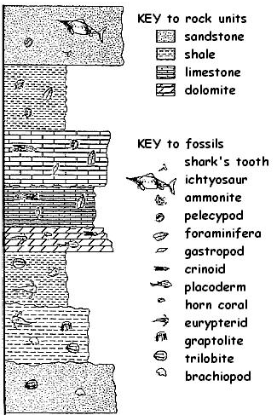
- this bivalve represents a genus that survived much longer than the graptolite genera.
- this bivalve genus lived in fairly deep water.
- this bivalve is a better index fossil than the graptolites

Answer: statement ii) and iii) were incorrect. According to the principle of superposition, the lowest layer is the oldest one and the top layer is the youngest one. If a type of bivalve is still present over the entire interval, it must have survived longer than any of the graptolite genera. Each graptolite genus only lasted as long as the time it took to accumulate the layer that contains it. Otherwise the same type of graptolites should have reappeared at a later time when conditions were again favourable for shale deposition. Because of their shorter timespan, the graptolite genera are better index fossils, i.e. rocks containing them can be inferred to have formed during the same time interval and that interval is significantly shorter than the period over which the bivalve genus lasted. A correlation based on graptolites is therefore more accurate.

Question #4 b) How can information about past sea level be deduced from this stratigraphic column?

Sandstone is a coarser-grained sediment than shale (both rock types are derived from continental weathering) and it accumulates mostly in river deltas and in nearshore marine environments. Shale forms from smaller mineral grains (mostly clays) which are transported further offsjore and deposited in deeper waters than sandstone. Limestones may form in shallow water (reefs) or deepwater (from small shells of certain types of plankton) . The types of organisms preserved in the limestone can also provide information about water depth.. The sequence suggests shallowest water at the beginning and the end.

Question #5.

- Among the list below, select four lines of evidence that one could combine to prove that an ice age affected a supercontinent Rodinia towards the end of the Proterozoic eon.

- the common presence of stromatolites on different continents
- similar sequences of banded iron formations, tillites and limestones found on several continents
- paleomagnetic data showing that most continents were at low latitudes
- layers of ancient lava (containing 700 million years old uranium-rich minerals) covering other rock types
- presence of glacial striations on rocks rich in trilobite and archaeocyathid fossils
- analyses of radioactive carbon 14 (half life: 5730 years) from marine limestones
- analyses of ¹⁸O/¹⁶O stable isotope ratios from stromatolitic marine limestones

The best combination was
"similar sequences of BIFs, tillites and limestones"
"layers of ancient datable lava covering other rock types"
^{"18}O/¹⁶O stable isotope ratios from stromatolitic marine limestones"

Two other statements could be useful if they were in the right time frame… They had value only if they were not combined with some dating technique (and the lavas were the only datable material in the list).
"stromatolites present on different continents" (useful only if their isotope ratios showed evidence of an ice age and they could be shown to be late Proterozoic)
"paleomagnetic data (from datable rocks) showing continents at low latitudes" towards the end of the Proterozoic eon (evidence of an ice age at low latitudes, i.e. at or near the tropics, would be strong evidence that this was a case of worldwide cooling).

Two statements did not support the hypothesis of a late Proterozoic ice age:
"radioactive carbon-14" has too short a half life to date such ancient rocks.
"glacial striations on rocks rich in trilobite and archeocyathid fossils" could not be late Proterozoic because the striations must be younger than the rocks, and these animals have nowhere been found in Proterozoic rocks.
- Sketch a stratigraphic column or use the sketch below to show how this information can prove that the ice age was of late Proterozoic age (not younger) and that it took place on a supercontinent present at that time.

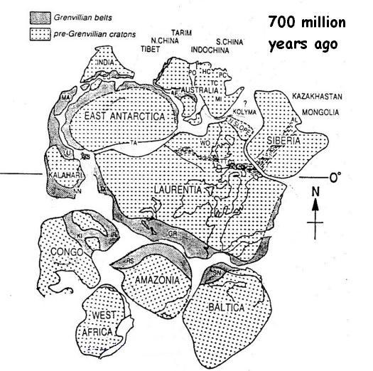
This question gave the most trouble to anyone who attempted it. As mentioned earlier, some lines of evidence are only useful if they are combined, and if we know the Proterozoic position of the continents from which the data were collected. This could have been discussed using this map (a reconstruction of the possible position of continents).
For example, the isotopic analyses of stromatolites would have been particularly convincing proof of a severe ice age if they showed cooling far away from the poles, e.g. from Laurentia (North America today).

You could have sketched a stratigraphic column showing layers rich in stromatolites that can be dated if they occur between layers of lava below and above them (so, absolute dates from the lava beds are known to be either earlier and later than the stromatolites). The BIFs (early Proterozoic), tillites (glacial deposits) and limestones (sign of warmer oceans) should occur from bottom to top in the stratigraphic sequence found on several continents if they record an ice age. The paleomagnetic data should come from rocks that are datable (the lavas themselves, for example) to be used in support of the hypothesis. The glacial striations on trilobites and archeocyathids should have been shown higher in the stratigraphic column than the stromatolitic limestones because these complex fossils are known worldwide to appear only in the Cambrian period.

