EPSC233 Earth & Life History

Mid-term examination - Wednesday October 16, 2002

This mid-term examination accounts for 25% of your total course grade.

Answer any four (4) of the five (5) questions. Each question is worth 25% of the total exam. If you get a false start on any one question, move on to the next one. Only the 4 best answers will be graded.

Question #1. The composition of ancient rocks and the fossils found in some of them can be interpreted as evidence that atmospheric oxygen rose progressively throughout the early Earth history. A) Order the statements below (numbered i to v) chronologically, from oldest to more recent events that unfolded as the level of atmospheric oxygen rose. B) Indicate which statements describe signs of prokaryotic life, and which ones describe signs of eukaryotic life.

- Impressions of limbless, mouthless life forms are preserved in some sandstones.
- Beds of ancient chert contain cell-like fossils that are never larger than 10 micrometers.
- Sandstones deposited in ancient river deltas were stained red when grains of pyrite (iron sulfide) eroded from the continent rusted to form iron oxide coatings on quartz grains.
- Microscopic fossils, 30 to 50 micrometers across, called acritarchs, became very diverse in sedimentary rocks.
- Rivers once carried pebbles of pyrite and uraninite without any sign that these minerals rusted away before becoming part of conglomerates.
- Grypania is a centimeter-size carbon-rich coiled ribbon found in some banded iron formations

Answer: The most accurate answer was v, vi, iii, iv, ii, i… There were two lines of evidence presented in these statements. One was the succession of rock types that reflect increasing amounts of atmospheric oxygen: uraninite-pyrite conglomerates, banded iron formations, sandstones… The other was the succession of increasingly complex fossil evidence of life which required increasing amounts of oxygen (dissolved in seawater): smallest single cells in Archean chert, larger cells that also more diverse, the larger multicellular Grypania, the Ediacaran fossils which are presrved in sandstones.

Question #2. Reefs have existed at various times throughout Earth's history but they were not always built by the same types of organisms.

- What life forms built reefs during the Precambrian ( = Archean + Proterozoic eons), the Cambrian period and the Ordovician period?

Answer: Cyanobacteria (prokaryotic cells, blue-green algae) built Precambrian stromatolites; archeocyathids (an extinct type of sponge) built Cambrian reefs; primitive corals, stromatoporoids and bryozoans built Ordovician reefs.

- Why are reefs such an important source of information about the diversity of ancient marine life?
Answer: in the past as today, reefs were populated by a diverse community of organisms. In addition to the reef builders, other animals used the reef as a substrate to anchor themselves, hid in its midst or roamed around it looking for prey. Unlike soft sea-floor sediment, reefs offer a solid structure from the start. During compaction, the framework remains largely intact and this means that many organisms associated with it are fossilized in the positions they occupied during their life. Although reefs declined in importance during certain periods, new organisms evolved repeatedly to take up the role of reef builders.

c) Reefal limestones preserve evidence of an Ordovician radiation of marine invertebrates. What does the term “radiation” mean?

Answer: radiation generally refers to the diversification of a given taxon (a group of organisms) within a relatively short interval of time. During a radiation, many groups (families, genera or species) related to a common ancestor appear nearly simultaneously in the fossil record.
Question #2. This diagram illustrates some of the elements mapped around the thrust-and-fold belt of the Proterozoic Wopmay orogen, in northwestern Canada.

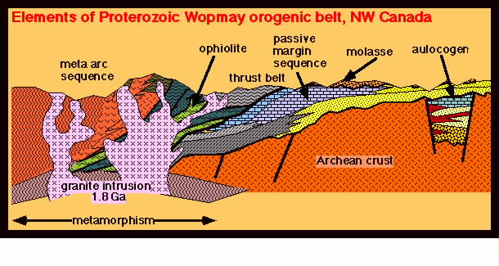
- Why can the granite intrusion be used to determine the youngest possible age of the Wopmay orogen?

Answer: The granite contains minerals that trapped radioactive elements from the magma during its crystallization, and its absolute age can therefore be determined by radiometric dating. This age must be the youngest possible age of the orogen (the episode of mountain building) because the granite cuts across (intrudes) the rocks that were pushed on the edge of the Archean continental crust during the plate collision that provoked the orogen.

- Is this type of tectonic activity most likely to have taken place at the edge of a Proterozoic continent, or near the center of the continent? Briefly justify your answer.

Answer: This type of activity is typical of a plate collision, which occurs at the edge of tectonic plates.

- Why are the sedimentary rocks different in composition in the “thrust-and-fold belt” (turbidites, shale and limestone), the “passive margin sequence” (sandstone and limestone) and the “molasse” (marine shallow-water and volcanic debris)? Your explanation should consider water depth and possible source(s) of material before and during the orogen.

Answer: The rocks now present in the thrust-and-fold belt that were deposited on the edge of the continent before the orogen, and pushed onto the edge of the continent during the orogen. They represent sediments originally deposited in moderately deep water (limestone) and deeper water (shale and turbidites). The “passive margin sequence” was also deposited on the edge of the continent, in shallower water (limestone) and closer to the seashore (sandstone). The “molasse” formed during and after the orogen, by erosion of the volcanic arc formed during the orogen and the shallow-water sediments raised above sealevel by the mountain-building activity.

This schematic stratigraphic column depicts a sequence of sedimentary rocks. A genus of bivalve has been found only in the sandstone layers (stippled pattern): one such layer is at the top and the other at the bottom of the column… Each of the three layers of shale (dashed pattern) found between the sandstones, shows different genera of graptolites.

NOTE: the question and the choice of answers did not draw your attention to any other fossils present in the column. All you needed to consider was the statement above and the relative position within the column of the stipped sandstone layers and the dashed shale layers.

Question #4 a) One or more of the following statements (i, ii or iii) is incorrect. Find out which one(s) and explain why it is false.

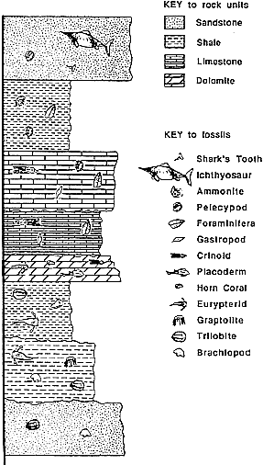
i) this bivalve represents a genus that survived much longer than the graptolite genera fossilized in the shales.

Answer: this statement is correct. According to the principle of superposition, the lowest layer is the oldest one and the top layer is the youngest one. If a type of bivalve is still present over the entire interval, it must have survived longer than graptolite genera. Each graptolite genus only lasted as long as the time it took to accumulate the layer that contains it, otherwise it should have reappeared at a later time when conditions were again favourable for shale deposition.

ii) this bivalve genus probably lived in fairly deep water.
Answer: this statement is false. Sandstone is a type of sedimentary rock typical of shallow-water (nearshore) environment.

iii) this bivalve is a better index fossil than graptolites.
Answer: this statement is false. If it had a longer timespan than any of the graptolite genera, the bivalve is a poorer index fossils, i.e. it will
Question #4 b). Can any information about sea level be deduced from the succession of rock types in this stratigraphic column? Explain your answer.

Question #4 b) How can information about past sea level be deduced from this stratigraphic column?

Answer: The rock types that are represented in this column reflect changes in relative sea level. Sandstones, limestones and shales generally accumulate in progressively deeper water. Sanstones are typical of nearshore and coastal environments and shales are typical of deeper water than sandstones. Limestones are typical of shallow-water shelf environments (but planktonic organisms also precipitate CaCO₃ in surface waters which accumulate in deeper water). The transition upward through the column from sandstone to limestones and shales suggests an increase in sea level, eventually followed by a drop (signalled by the return to a sandstone at the top of the column).

Question #5.

- Among the list below, select four lines of evidence that one could combine to prove that an ice age affected a supercontinent Rodinia towards the end of the Proterozoic eon.

i) the common presence of stromatolites on different continents

ii) similar sequences of banded iron formations, tillites and limestones found on several continents

iii) paleomagnetic data showing that most continents were at low latitudes

iv) layers of ancient lava (containing 700 milliion years old uranium-rich minerals) covering other rock types

v) presence of glacial striations on rocks rich in trilobite and archaeocyathid fossils

vi) analyses of radioactive carbon 14 (half life: 5730 years) from marine limestones

vii) analyses of ¹⁸O/¹⁶O stable isotope ratios from stromatolitic marine limestones

NOTE: the evidence must cover the three elements of the question, i.e. indicate that a glaciation occurred, but it must also be consistent with the age given, and the position of the continents at the time must be determined to prove that this took place on a supercontinent. There was latitude in the grading for several combinations, but the best one was…

