Question 1.

ASTEROZOANS

Examine any one of the dried starfish and look for the features (1a) to (1e) listed below.

If the feature is present, indicate
- where do you find it?
on top (adapical) or bottom (= ventral, adoral) surface
- is it centered or off-centered relative to the body symmetry?
- is it single or repeated by a 5-fold symmetry?

(1a) madreporite: this small plate opens the water vascular system to seawater while acting as an effective filter, keeping out floating particles and living organisms such as parasites that might harm the sea star. Look carefully: it is usually about 1/50 th of the diameter of the sea star’s arms, so it can be easily missed when you observe these echinoderms.

When 18th century biologists studied sea stars closely with a microscope, they thought this structure looked like a miniature brain coral. Brain corals are a group of scleractinians called the madreporian corals, so the name of this structure in starfish became… the madreporite.

(1b) deep grooves through which tube feet stick out
(1c) periproct: area containing the anus.
(1d) peristome: area containing the mouth.
(1e) Aristotle’s lantern (a chewing apparatus)
Questions 2a-c.

Compare specimens of modern starfish (subphylum ASTEROZOA) and the sea urchin Strongylocentrotus (an
euechinoid from the subphylum ECHINOZOA).

The ambulacral areas are sectors where tube feet (extensions of the water-vascular system) stick out of the body.

In starfish, the ambulacra are deep grooves on the underside (adoral surface). What do the ambulacra look like in a sea urchin, and are they located in the same place as on a starfish(2a)?

Are there visible pores in both the ambulacral and interambulacral plates of the sea urchin (2b)? These pores are where the tube feet stick out.

How do the relative position and size of the anus, mouth, madreporite and Aristotle’s lantern compare in a starfish and a sea urchin (2c)?

NOTE: The diagram (next page) is for a cidaroid, but the same overall body plan applies to Strongylocentrotus.

Question 2.
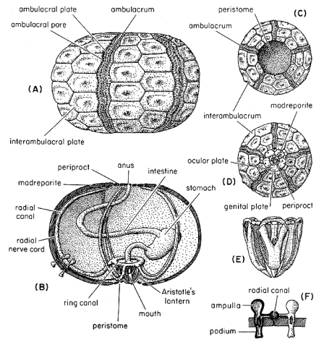Body plan of an echinoid.
Question 3.

Subphylum ELEUTHEROZOA

Class ECHINOIDEA

Subclass CIDAROIDEA vs EUECHINOIDEA

Compare, in a few words, the following features of the test of a cidaroid with those of an euechinoid like Strongylocentrotus.

(3a) number of radial segments (ambulacral and interambulacral areas) extending from the apical disc (set of small plates at top) to the peristome.

(3b) relative width of the ambulacral and interambulacral areas (as some zones wider in one type of echinoid than in the other)?

(3c) overall shape (globular, flattened)?

(3d) pentameral (five-fold) symmetry (is it as perfect in both types of echinoids, or noticeably distorted in one of them)?

(3e) size and number of tubercles (the knobs covering the test, on which the spines articulate)?

Observation only

Subphylum ELEUTHEROZOA

Class ECHINOIDEA

Subclass CIDAROIDEA vs EUECHINOIDEA

Cidaroids are noteworthy for the remarkable development of their spines. Fusiform, club-shaped and peculiarly-shaped spines are seen in the shallow-water genera.

Most cidaroids are sluggish and the heavy spines seem to be used for stabilizing them in rough water.

Slender, elongate spines are more usual in the deeper-water or mud-living species.
Question 4.

Subclass Euechinoidea

Order Spatangoidea: the "irregular" echinoids

Compare the regular euechinoid, Strongylocentrotus, to any one of the irregular echinoids (Micraster, Ellenaster, etc.). Irregular echinoids (spatangoids) evolved from euechinoids and adapted to a burrowing mode of life during the Mesozoic.
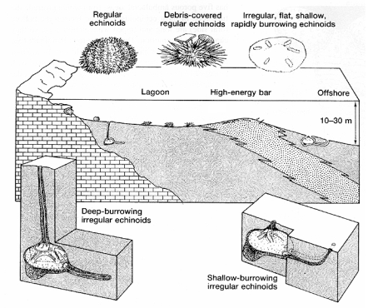
Examine the periproct (area of anus) of Strongylocentrotus. It is located centrally within an apical disk, i.e. a series of small plates (called genital and ocular plates).

Is this apical disk still distinct and centered on top of the test in a spatangoid such as Micraster (4a)?

How does the position of the peristome (i.e. opening for the mouth) differ between regular vs. irregular echinoids (4b)?
Question 5.

Subclass Euechinoidea

Order Spatangoidea: the "irregular" echinoids

Examine Echinocorys or Micraster.

Is there any evidence of tubercles for spines on their surfaces (5a)? How is this different from the tubercles on regular euechinoids such as Strongylocentrotus (5b)?

Observation

Subclass Euechinoidea

Order Clyperasteroid: sea biscuits, sand dollars

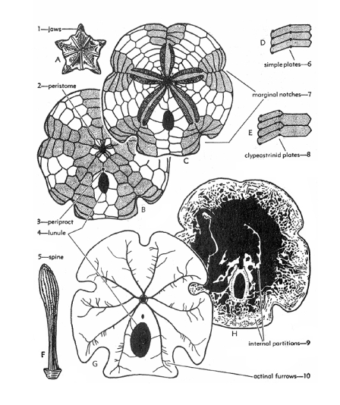
Look at the specimens (e.g. Mellita) and note the following features:

- Petal-like shape of the ambulacral areas

- Groove pattern on adoral surface

- Lunules in some specimens

- Buttresses inside the test

These are adaptations to a semi-infaunal mode of life.

What is the reason for the rattling sound you get when shaking some of the sand dollars?
Observation

Subphylum ELEUTHEROZOA

Class HOLOTHUROIDEA (Ordovician to Recent)

Holothurians reduced the endoskeleton in a trade-off giving them more flexibility. They lie on the seafloor (or burrow into it) with their long axis horizontal, creeping on their tube-feet and sweeping organic detritus with them. A few are planktivorous swimmers and keep themselves afloat by pulsation, like jellyfish.

Their skin is warty and leathery. Within it are embedded the calcitic elements (sclerites shaped like anchors, gratings or spoked wheels) that are the only parts to be fossilized.

Can you see any evidence of the ambulacra? If they were preserved, they should surround the mouth and be arranged parallel to the long axis of the body: three ventrally, and two dorsally.
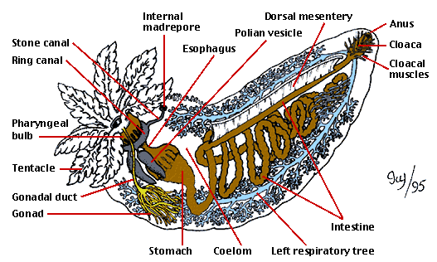

Observation

Subphylum HOMALOZOA – Class STYLOPHORA

No specimens are available for study but there is one in the foreground of the Ordovician diorama from the lobby of the Redpath Museum. Look for a blue plated body with one segmented appendage on one end and two smaller appendages at the other.

These animals, also known as carpoids, present a truly weird mixture of characteristics from echinoderms and chordates. On one side, the skeleton shows a series of slit-like openings that have been compared to the slit systems of primitive chordates (the phylum including the vertebrates). On that basis, some researchers consider carpoids as members of a group that gave rise to the vertebrates.

What different (and contradictory) interpretations could be offered for the function of the appendage (6a) in such an animal? How could the discovery of a trace fossil help test your hypothesis (6b) ?
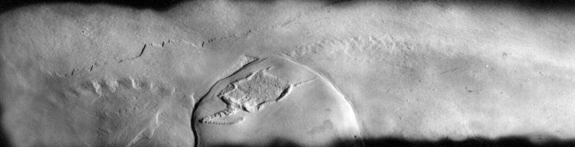
from:"Ichnological evidence on the behaviour of mitrates: two trails associated with the Devonian mitrate Rhenocystis." Coauthors: O.E. Sutcliffe & R.P.S. Jefferies. In: Lethaia (2000), vol. 33, pp. 1-12
Question 7

BLASTOZOA - CYSTOIDS

Cystoids: a group of extinct Paleozoic echinoderms

Class RHOMBIFERA

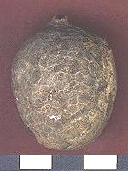
Echinosphaerites - Examine the smooth calyx. The hexagonal plates with sutures are difficult to distinguish. Each plate has a pore-rhomb system (explained in question 8) which can be seen only when the plate is weathered.

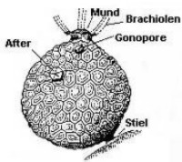
Is there any evidence of a 5-fold symmetry in the pattern of its food grooves or the arrangement of plates forming the calyx (7)?

Some cystoids (but not all) have robust, crinoid-like stems.

Can you see why the cystoid Echinosphaerites has been nicknamed "crystal apple" by amateur paleontologists?
Question 8a, 8b.

BLASTOZOA

CYSTOIDS are characterized by a complex respiratory system showing pores in plates all over the theca (theca: name given when the calyx is not cup-shaped, but plated all over with similar-looking plates). How is this different from the respiratory system of crinoids (8a)?

CYSTOIDS were never as diverse, widespread or numerous as the crinoids. Paleogeographic studies suggest that they were largely restricted to the warm waters of tropical latitudes and excluded from higher latitudes.

Remember the effect of water temperature on its oxygen content: what does the paleogeography of CYSTOIDS suggest about the efficiency of their respiratory system relative to the crinoids(8b)?
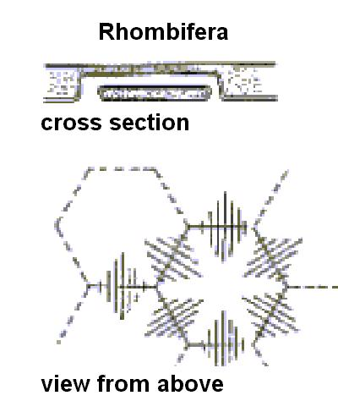
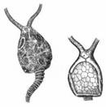Question 8c.

Subphylum BLASTOZOA

Class RHOMBIFERA

Cheirocrinus - Plates of this form are common in the local Ordovician Chazy limestones. They are characterized by a radially ridged ornament and pore-rhombs.
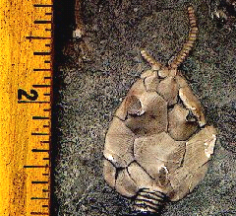
Pleurocystites - This rhombifer resembles the carpoids (cf. Question 6) in its lack of symmetry and the different plate arrangements on each side. What does this asymmetry suggest about its living position (8c)?

Look for evidence of the pectinirhombs, arms, and stem. Which one of these characteristic does distinguish this fossil from a carpoid (8d)?
Question 9.

Subphylum BLASTOZOA

Class BLASTOIDEA

Answer the following questions about Pentremites, the commonest blastoid in Upper Carboniferous limestones of central North America. Use the diagram at the bottom of the page to help you find these features:
- does the calyx show pentameral (i.e. 5-fold) symmetry (9a)?
- are there ambulacral areas (9b)?
- are there any visible pores on the theca (9c)?

Do these traits suggest a different living position from the flattened rhombifer Pleurocystites, seen in Question 8 (9d)?

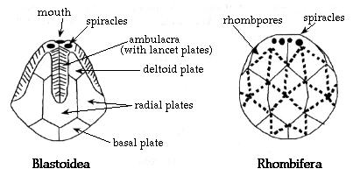Question 10.

Subphylum BLASTOZOA

Class PARACRINOIDEA

Another small group that appeared during the Ordovician.

Malocystites - Find specimens which show the pattern of the five food grooves spreading over the upper surface (make sure you look at several specimens).

Do the grooves suggest that the plates were arranged according to a regular 5-fold symmetry (10)?

Paracrinoids, like other blastozoans, show no evidence of well developed arms. They probably filtered water using short, delicate brachioles that are rarely preserved. The mouth was hidden under plates of the calyx.
Observation

Subphylum BLASTOZOA

Class BLASTOIDEA

The triangular plates of Blastoidocrinus are common in the local Chazy limestones. Can you find any in the specimen on display?

Codaster - Examine specimens of this genus and note the small ambulacral areas high on the calyx. The hydrospires are represented by small infolds in the plates near the ambulacral areas.

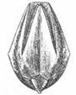
Also examine specimens of Nucleocrinus. In this genus, the thin ambulacra run down the whole length of the calyx.

None of the blastoids developed large arms. They filtered water using short brachioles which are rarely fossilized.
Observation

Subphylum Crinozoa

Class CRINOIDEA

Examine the preserved specimen of a Recent "feather star" from Barbados. This is a free swimming modern crinoid. Note the very small calyx, the long arms, and the cirri at the base of the stem for grasping.

The diagram (below) is a view of a feather star seen from above. Note that the calyx is roofed over by the tegmen, a tough organic covering that is a different material from the calcite-plated calyx of most Paleozoic crinoids.
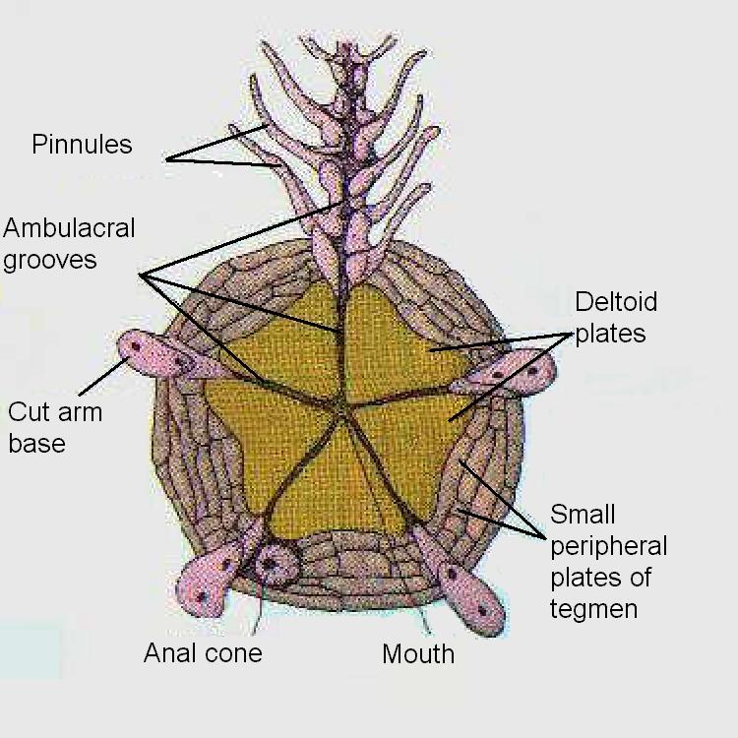
Question 11.

Subphylum Crinozoa
Class CRINOIDEA

The columnals of crinoids often show radial grooves which
insured a tight fit on the interlocking surfaces. Some show a median ridge which allowed the individual ossicles to rock against each other and gave the stem flexibility.

Look for two different types of columnals (in side view or in plan view) among the specimens on display and sketch them (11a and 11b). Be careful not to confuse fragments of stems and fragments of arms (the latter usually contain ambulacra, i.e. zipper-like pairs of imbricated plates).

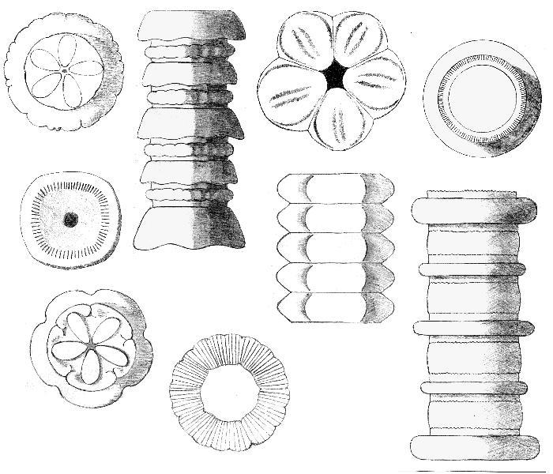
Here are some examples of the diversity found in the columnals and stems of Paleozoic crinoids.

Question 12.

Class CRINOIDEA

Examine the specimens selected for this station.

How would you tell apart the root system (labelled "4" on the drawing below) of a crinoid from its "crown " (i.e. the arms, labelled "1" on the drawing) in these specimens (12)?

Note: the "root" is strictly an anchoring system. It does not draw any food from the substrate as plant roots do.

